In All My Years: Exploring the Social and Artistic Elements of African American Photography
McNair Summer Research Program
By: Sydney Stoudmire
Mentor: Professor Dana Rush
8/6/10
Abstract

In October 1983, artist photographer Raymond Bill of Urbana, Illinois began working on a photograph exhibition to celebrate the accomplishments and contributions of African Americans in the Champaign-Urbana community. The exhibition, titled In All My Years: Portraits of Older Blacks in Urbana Champaign, featured black and white portraits of fifty-five elderly African Americans, accompanied by vignettes that offered glimpses of the individuals portrayed. Although it was created to spur interest in documenting African American history, nearly thirty years later, it remains one of the few efforts made to examine black history in the two cities. In contribution to increasing critical discussions about African American history, this study examines In All My Years from two perspectives. It is first analyzed for its aesthetic and visual elements, and then socio-cultural function of the photographs is explored. The conventions of fine art photography are then discussed and challenged in relation to Raymond Bial’s photographs, along with the works of well-known African American artist photographers. Published research on African American photography from an art historical and social perspective is very rare, and the goal of this study is to encourage further research on African American contributions to art and history.

Acknowledgements
I would like to thank the Dr. Priscilla Fortier and Dr. Celina Trujillo, for giving me the opportunity to participate in the McNair Summer Research Program. It has been an eye-opening experience, and I will value it as this summer.
I also wish to acknowledge all of the students in Professor Rush’s Fall 2009 art history seminar, with a special thanks to Rick Deja, Stephanie Birch, and Emily Heaton. Your hard work and research has greatly aided me, and I am appreciative of your efforts.
Finally, I would like to thank my advisor, Professor Dana Rush for her continued support throughout my research experience. I couldn’t have asked for a better mentor. Thank you.

Ever since its introduction to the United States in 1839, photography has been one of America’s favorite pastimes. The versatility of the medium makes it accessible to anyone, from the amateur to the professional. Whether photography is used to capture images of armed conflict and war, or a candid family moment, it remains a significant part of American culture. Photography seems have been rigorously researched, debated, and analyzed from many angles, ranging from technical concept to the social function of the photograph. However, there remains at least one area of photography that is underrepresented: photos of and by African Americans.
Despite the scholarly attempts in exploring the many facets of photography, those which regard African Americans have in large part been overlooked. Although African Americans have made significant contributions to the field of photography as both subjects and makers, there are very limited publications acknowledging these contributions. Deborah Willis, Professor and Chair of the Department of Photography at Ticsh School of the Arts at New York University, is one of few art historians who has published research on African American photography. She is considered the nation’s leading experts on the topic, as she was one of the first historians of photography to discuss the social significance of the photograph in the black community.
In an essay titled “Visualizing Memory: Photographs and the Art of Biography,” Willis discusses how photographs are “powerful storytelling devices and instruments of memory,” and the way visual images make up for where written history falls short in within Black America. “Throughout my life I have found that photographs of the family, pictures that function as biography and autobiography, are an important way to reenter the past and comment on social issues,” Willis writes.
The biographical quality of the photograph was also recognized by Urbana, Illinois art photographer, Raymond Bial, who spent most his early career visually documenting communities that were historically underrepresented. Because African Americans in the Champaign-Urbana community had been excluded in public records and rarely included in standard local histories, in 1983 he began working on a documentary photography exhibition that would celebrate African American accomplishments and contributions. He was inspired by a similar project that had been conducted by the Douglass Branch of the Champaign Public Library. For this project, Charlotte Nesbitt, Director of the Douglass Branch Library at the time, invited older African Americans who played significant roles in their community for audio interviews on their experiences in Champaign-Urbana. The Illinois Humanities Council, an organization that funded the Douglas Branch oral history project, hired Raymond Bial to take photographs of the individuals who gave oral interviews. After completing his role in the project, Bial decided to continue the efforts of the Douglass Branch Library and create a photo exhibition of his own.
In a format similar to that of the oral history project, Bial photographed and interviewed fifty-five individuals, all of whom were senior citizens. Based on the interviews, Bial wrote vignettes for each person to accompany the photographs. The exhibition and accompanying book were entitled In All My Years: Portraits of Older Blacks in Champaign Urbana, and had their debut at the Champaign County Memorial Museum in June 1983.
Members of the community were ecstatic to see an exhibition in honor of African Americans, as it was the first time their lives and contributions had been publicly acknowledged in this way. Aside from an occasional article in Champaign-Urbana’s main news source, the News Gazette, and black-owned newspapers, African Americans were rarely acknowledged for their contributions to the Champaign community. There have since been community projects and a doctoral dissertation and few community projects devoted to researching black history but for the most part, the documentation of African Americans in Champaign remains insuffient.
The question of why varying aspects of black history and culture in the Champaign community are not sufficiently documented is subject to debate. Whose burden (or responsibility) is to document black history? What is certain is courses on various topics in African American history are rare at colleges throughout the country, the University of Illinois in Urbana-Champaign included. While there has been an increase in the formation of African American Studies programs at universities in the United States, the availability of scholarly research on topics in African American history is extremely limited. With the exception of courses offered at Historically Black Colleges and Universities (HBCUs), it is very difficult to find survey history courses, in which mainstream curriculum includes the contributions of African Americans.
Although the representation of black history in the academy is insufficient, there are areas that are less explored than others. Art history is one such discipline where the absence of African Americans in is quite noticeable. Based on my own experiences as the University of Illinois, and in researching art history programs throughout the United States, courses surveying African American contributions to art are extremely rare, while concentrations on African American art seem simply non-existent. In an effort to increase the interest in critical discussions about African American art and history, this paper will examine In All My Years from both a social and art historical perspective. I first examine the photographs in a socio-cultural context, highlighting the themes of family, spirituality, and community that radiate throughout the book. I then analyze them for their visual elements, with details and descriptions of what Raymond Bial wanted to convey aesthetically. In relation to Raymond Bial’s work, I also discuss the conventions of fine art photography and what elements make the photographs “art.”
Because all fifty-five photographs in the book cannot be analyzed in this short paper, I have selected five to examine. The six individuals in these five photographs are as follows: Allen Rivers, a well respected member of the armed forces; Sarah Scott, a woman known for her commitment to servicing her community; Brothers Al and James Baker, owners of the Blue Island Tavern, an establishment in Champaign that operated for 39 years; James “Biggie” Algee, a man who man who lived a quiet lifestyle and was recognized for his passion for cooking; and Taylor Thomas, a well respected man known for his dedication to education, athletics, and civil rights in the community. These six individuals embody the spirit of In All My Years, and are representative of the prevailing themes of strong family values and pride in one’s community.
While the dichotomy between the photograph and its social implications have been explored by African American many artists, the critical analysis of African American photography in an artistic and social context as an aspect of photography, are far more rare. The interest in African American photographs has begun to peak in the last decade however it is more for their social-historical relevance than for their artistic merit. This project is innovative in that I am analyzing photographs of the African American community from a socio-cultural-art-historical perspective in an effort to encourage further academic research and discussions on African American contributions to art and history. More broadly, the objective of this examination is to continue increasing interest in the documentation and discussion of black history, not only in Champaign-Urbana, but throughout the country.

Literature Review
Through the analysis of Raymond Bial’s In All My Years, I am suggesting that African American photographs be examined from an art historical perspective, in the same manner many other documentary photographs are. To support this suggestion, I will first briefly discuss what has been written on art photography and the social significance of the photograph in the black community.
Deborah Willis has written over twenty books, and curated several exhibitions devoted to images of and by African Americans taken between the late 1890s through the present. It appears that she has devoted most of her career to this because black history is not yet considered a standard requirement in academia, much less is a familiarity with the history of African American photography.
Her works focus primarily on themes of family, endurance, spirituality, and celebrating the diverse range of the black experience. In her publications, Willis frequently addresses the significance of the photograph in the African American community, and the role it plays in creating a positive identity. In her book, Picturing Us: African American Identity in Photography, Willis writes about the significance of photographs in her life:
[The Sweet Flypaper of Life by Langston Hughes and Roy DeCarava] was the first book I had ever seen with ‘colored’ people in it—people that I recognized; people that reminded me of my own family…Sweet Flypaper spoke of pride in the African American family, good times and hard times, with an emphasis on work and unemployment. Sweet Flypaper said to me that there was a place for black people’s stories. Their ordinary stories were alive and important and to be cherished.

The sentiments that Sweet Flypaper of Life evoked in Willis are quite similar to the response Champaign-Urbana’s African American community had to In All My Years. Over twenty years after the exhibition’s debut, residents of Champaign still beam with pride as they reminisce about the people in the book. The exhibition resonates in the African American community, and the catalogue is considered by many to be a local history book. The photographs represent much more than images of family and friends; they represent some of the most positive aspects of the black community.
In the “Social and Artistic Movements” chapter of her book Reflections in Black: a History of Black Photographers 1840 to the Present, Willis writes about the impact of photography in the black community during the Civil Rights Movement:
The most brutalizing events [of the Civil Rights Movement] caused photographers to speak out en masse. Images convincingly told the story, and the activities of the modern civil rights movement were well documented by black photographers in this country.

Willis explains that for many African Americans during the Civil Rights Movement, photography was “a testimony to the depth of understanding and love these photographers had for humanity.” As photographer Robert Sengstacke states:
We saw ourselves as graphic historians; conveyors of love, combating what we felt were negative photographic images of blacks in the major American press. Whether we achieved recognition or not, we knew that someday people would look back and want to know what the black photographer had to say about his experience.

In the introduction to the catalogue created in conjunction with the In All My Years exhibition, photographer Raymond Bial explains the intent of the project in a way similar to Robert Sengstacke:
We were primarily interested in evoking the strength and dignity of individuals who have not only endured, but eventually prevailed through very difficult times. What has emerged is a composite picture—strikingly at variance with traditional stereotypes—of individuals who have valued family, church, community, and themselves as human beings.

Both Raymond Bial and Robert Sengstacke emphasize the power of the photograph in portraying positive aspects of African American life. According to art historian Brian Wallis, after a long history of being portrayed in derogatory and crude ways, African Americans “increasingly gained access to photography—as sitters, photographers, amateur snap-shooters.” He continues by asserting that “black Americans began to reproduce aspects of social life that, while never free from oppression, at least began to rise above it.” Although Bial himself is not African American, his aim for the In All My Years exhibition was the same as many black photographers working within the same genre: to capture the contributions of African Americans to their communities, and to counter negative images that frequently appeared in the mass media.
In addition to being recognized for her writing on the topic of African American photographic history, Deborah Willis, like Raymond Bial, is an art photographer who commonly uses human subjects in her work. By the way she describes her art, it is evident that her beliefs about the significance of the photograph in the black community plays a role in her work as an artist:
My studio art has focused on the notion of photography as biography…I photograph and use my own family photographs and archival references to incorporate stories and social politics into my art, hoping to invite a larger public to imagine the experiences—both collective and individual—of African Americans in the nineteenth, twentieth, and twenty first centuries.

In several of her online biographies, Willis’ contributions to art photography and art history are recognized as divergent careers. However, her writing suggests that Willis believes photographic art and social history intertwine:
Autobiography is essential to my work, and I see and use photographs as evidence of particular experiences. Biography is useful in exploring the cultural values, traditions, and perceptions in the black community…I remain concerned with the present and its links to the past: identity through its connection to community and ideas that are fully imagined through the art-making process.

Despite the fact that Willis draws from black social history to create her art, her books and exhibitions do not explore the relationship between this important history and how it effects her artistic production. While most of the black photographs she researches may fall under the vernacular or documentary category, many of them contain the compositional elements found in “artistic” photographs. What then are the elements that make photographs that were not necessarily intended to be art, acceptable as art.?
Whether or not photography can be considered a “fine art” is a subjective debate with no universally accepted answer. However, there are still certain properties that artists and art historians believe constitute a fine art photograph. The principles of fine art photography, as it began to be regarded as a true art form, were rooted in philosophies of aesthetics and art in general. Russian writer Leo Tolstoy wrote What is Art? in 1898. Although he is best known for his fictional works What is Art? remains a relevant text on the doctrine of art and aesthetics. In chapter five, Tolstoy writes what he believes is true purpose of art:
To evoke in oneself a feeling one has experienced, and having evoked it in itself, then, by means of movements, lines, colors, sounds, or forms expressed in words, so to transmit that feeling that others experience the same feeling—this is the activity of art. Art is a human activity consisting in this, that one man consciously, by means of certain external signs, hands on to others feelings he has lived through, so that other people are infected by these feelings and also experience them.

Tolstoy’s assessment of art as being a process of emotional transference is one that African Americanist art historian, Barry Gaither, may agree with. In his essay “Social Art,” Gaither describes African American art of the 1960s as being reactionary to what they experienced during their fight for civil rights:
Black art had roots in: a) the activism of the Civil Rights Movement; b) rising cultural and political nationalism; c) latent resentment of racism and its humiliations; and d) outrage over the brutal treatment of blacks struggling non-violently to gain the most basic rights.

As Tolstoy’s and Gaither’s explanations suggest, artists draw from their own experiences, and their works are often an attempt to communicate those experiences.
Charles “Teenie” Harris, an African American photographer who worked for the Pittsburg Courier from 1936 to 1975, is known for the thousands of photographs he took that glorified the black American life. Deborah Willis writes that Charles Harris’ photographs “boasted community wealth and pride…They also illustrate the economic and political successes of struggling and working class residents and documenting the realities of urban life…in a profound and expressive manner.” Harris’ powerful images of African American urban life do not only reflect the struggles and triumphs of people in the photographs; they reflect his own struggles and triumphs because the plight of the black photographer was often no different from that of the black American. Although photographs taken by Charles Harris may not have been self-portraits, he most likely identified with them on many levels.
Paul Anderson, an American photographer and author, describes the function of art in a way similar to Tolstoy. In his book entitled The Fine Art of Photography, published in 1919, Anderson provided guidance to aspiring art photographers. His suggestions ranged from the technical to the conceptual. In one section of his book, Anderson explains a key component of fine art how it translates into fine art photography:
Since every fine art must be capable of conveying an idea or stimulating an emotion, it follows that it must possess some intellectual quality, for the term “emotion” implies this…For this reason…it is within the power of photography to express and to stimulate emotions such as joy, calm, peace, hope, horror, and the like.

Roland Barthes, a French literary theorist and philosopher, also wrote about the emotional capacity of the photograph in a way similar to Anderson. In Camera Lucida, considered to be one of the most important early academic books on the criticism of photography, Barthes engages in a discussion of the lasting emotional effect of certain photographs. In the chapter titled, “The Studium and Punctum,” Barthes describes the evocative power of photograph in this way:
It is by studium that I am interested in so many photographs, whether I receive them as political testimony or enjoy them as good historical scenes: for it is culturally that I participate in the figures, the faces, the gestures, the settings, the actions…The second element will break (or puncture) the studium. This time it is not I who seek it out, it is this element which rises from the scene, shoots out of it like an arrow, and pierces me…The second element I shall therefore call punctum.

Both Anderson and Barthes comment on the photograph’s ability to arouse emotions in the viewer. In response to a J. Paul Getty Museum exhibition called Hidden Witness: African Americans in Early Photography, which featured rare photographs of African Americans between the pre-civil war dates of 1840s and 1860s, Carrie Mae Weems began working on her own exhibition of the thirty-three photographs. She re-photographed the images and, using her famous text-over-photo technique, Weems created a contemporary narrative that challenged the institutional display of these problematic photographs.
Titled From Here I Saw What Happened and I Cried, the collection of Carrie Mae Weems photographs are quite emotionally startling. The first four photographs of the collection are evocative of prison mug-shots, as the individuals, with grim expressions, face the camera head-on or are presented in profile. The images are also reminiscent of scientific and ethnographic studies in the way the individuals stand shirtless against an unobstructed background. The text that appears on the four photographs suggests that Weems interpreted them as the latter. They read, “YOU BECAME A SCIENTIFIC PROFILE…A NEGROID TYPE…AN ANTRHOPOLOGICAL DEBATE…& A PHOTOGRAPHIC SUBJECT” (Figures 1, 2, 3, and 4).
Along with adding text to the photographs, Weems also tinted the images in a blood-red coloring. If the punctum is what Barthes describes as what “pricks and…bruises me,” then the addition of the red tint is certainly what ”pricks and bruises” most in the photographs.
The photographs in their original state may have already been quite haunting. But to see these individuals—whose expressions range from melancholy and despondency to anger and resentment—in a scarlet-red hue, truly invokes the violence and injustice of slavery. The effect of the red coloring intensifies the emotion and the misery in the eyes of the individuals becomes even more poignant. Although it is impossible to imagine what enslavement feels like, Paul Anderson explains, the photographs do successfully stimulate feelings of “horror.”
The works of Deborah Willis, Charles Harris, and Carrie Mae Weems all embody the elements of art photography that art philosophers deem critical. Although all of the photographic examples have a documentary quality, they each tell a story of the individuals depicted and successfully stimulate an emotion of their experiences. Given that their works meet the criteria that defines a work of art, it can then be said that African American documentary photographs certainly do qualify as art, or that they at least deserve an art historical analysis.
In All My Years: An Art-Historical-Socio-Cultural Analysis
The following analysis of Raymond Bial’s In All My Years photographs differs slightly from the analysis of the previously mentioned photographers. Several factors contribute to the distinction: Unlike Carrie Mae Weems’ photographs, which were appropriated, Bial actually took these photographs himself; Charles Harris, who identified himself as a photographer, Bial considers himself an artist; and finally, the main difference between Bial and all of the aforementioned photographers is that he is not African American; he is Caucasian.
Although they all identify as artist photographers, Deborah Willis’ and Carrie Mae Weems’ identification as African Americans influences their art in a way Raymond Bial’s work does not. However, despite not identifying as an African American, Bial believes he possesses the cultural sensitivity necessary to document black society in the photographic medium. In Bial’s brief online biography, he said:
Essentially, I have been devoted to a quest for excellence in writing and photography. As a serious writer and photographic artist, I have committed myself only to those projects that have mattered deeply to me. Furthermore, I have only published books for which I have felt a compelling need to learn more about a particular subject or better understand another culture.

Bial has published several photographic books on “other” American cultures, histories , and. Select titles include, Frontier Home, Shaker Home, The Underground Railroad, Mist over the Mountains: Appalachia and Its People, and Tenement: Immigrant Life on the Lower East Side. He has also published a twenty-eight book series about Native American people entitled “Lifeways.” Shortly after completing this critically acclaimed series, Bial began working on a set of five books called “Building American.” Bial has other books which he describes as showing “how people worked hard to settle various regions of the United States.” The following titles give clues to the type of work represented in the series: The Canals, The Farms, The Forts, The Homes, and The Mills.
Given Bial’s commitment to photographing underrepresented (and underappreciated) people of American culture, his interest in photographing senior citizens of Champaign-Urbana’s African American community should come as no surprise. In All My Years was simply one of Bial’s many attempts to photographically celebrate a group of people who were rarely acknowledged for their contributions to American society.
Raymond Bial credits Charlotte Nesbitt, former Director of the Douglas Branch Library, for bringing all of the participants in the exhibition to his attention. Although many were featured in the oral history project mentioned above, most of the individuals were selected based on their roles as leaders in the community. According to Bial:
We photographed people who successfully managed businesses when the odds were decidedly against them. We also photographed articulate people who all their lives found themselves relegated to service occupations, but nonetheless excelled in those avenues available to them and, most importantly, maintained their essential humanity.

In order to visually communicate the successes of these individuals, Raymond Bial photographed all of the participants of the In All My Years exhibition in one of two ways: either in front of a simple black back-drop, or in their homes or places of business. Bial explains that he wanted to demonstrate the multiple layers of the African American community by creating an equal balance between “character studies” and “environmental studies.” That is, he wanted to create photographs that emphasized the essence and personalities of the individuals represented, as well as photographs that were reflective of their environments.
He also chose to print all of the photographs in black and white. He believed that while colored photographs are beautiful, it takes more skill to make a black and white photograph interesting. As Bial explains, he:
…Quickly came to appreciate black and white images, notably the ability of the interplay of light and shadow to evoke a distinctive mood through which I could both document a subject and express myself. My photographs were meant to be art, with significant content, not just because they were carefully made, but because they evoked profound feelings.

Bial’s ability to simultaneously document the individuals in the exhibition, while expressing himself as a photographic artist, were the key components that made the In All My Years successful. Bial was committed to making photographs that not only represented his aesthetic vision, but also represented the individuals featured in a way that was dignified and noble.
The five following photographs (six individuals) I have chosen to discuss were selected based on their visual qualities, diversity of their themes, a balance of gender, and equal representation of character/environmental studies. All of the biographical information provided on the participants in the exhibition is based on research conducted by students in an art history seminar taught by Professor Dana Rush at the University of Illinois in Fall 2009. The class was structured around the In All My Years exhibition catalogue. Each student was assigned several participants from the book, and required research their individual and family histories. They gathered obtained their information by extensively researching libraries, archives, and the community itself.

Allen Rivers
Born in Cache, Illinois on December 2, 1902, Allen Rivers Sr. was Champaign’s first African American police officer (Figure 5). Champaign and neighboring cities were not known for hiring African American officers, so Rivers’ appointment was quite significant. He served in the police force for twenty-five years until he retired in 1960. While it may have been effective to photograph Mr. Rivers at the Champaign police department while wearing his uniform, Bial opted for a simple tightly cropped portrait with a black backdrop. Bial wanted the photograph to communicate the accomplishments of Rivers’ nearly thirty-year career, but also represent the personality of the man he had become because, by the time the photograph was taken, he had been retired for over twenty years.
In Mr. Rivers’ photograph, he wears a white dress shirt, with a tie and black suit jacket. His jacket fades into the darkness of the black back-drop, making Mr. Rivers’ face the focal point of the photograph. His salt and pepper hair is neatly trimmed, along with his moustache; there literally is not a hair out of place.
The expression he wears is one of that communicates the necessarily stern demeanor of a police officer, and a disciplinarian. His stare could be viewed as intimidating and severe, however, Bial explained that River’s expression was just an extension of his personality. Even after his retirement, Rivers was known for being a no-nonsense man, and lived by a strict code of ethics. The photograph reflects the essence of a man who demanded respect, but also one who had respect for others.
Beyond his duties in the police force, Rivers was active in the community. Rivers offered support as a mentor to African American football players at the University of Illinois for fourteen years. He served on the Champaign Park District Board, and a member of the Frederick Douglas Recreational Center. Rivers was also a steward and trustee of Bethel AME Church, and a member of the Urban League. In addition, he was a 33rd degree Mason, and a grand master of Lone Start Lodge No. 18, Prince Hall Masons, of Champaign. Allen Rivers passed away November 12, 1982 and Allen Rivers Sr. Street was named in his honor in May 24, 2009.
Sarah Scott
Sarah Scott was one of the twenty-six women featured in the exhibition. Born June 29, 1892 in Shawneetown, Illinois, Scott came to Champaign in 1911 (Figure 6). In a 1979 interview, Scott recalls how she was disappointed in the race relations of Champaign when she arrived, and expected conditions to be better than they were in the south. She explains that for nearly fifty years she did housework because service occupations were was the only option for many African American women at the time. Sarah Scott was married to Raymond M. Scott, who was a saxophonist and longtime employee at the University of Illinois. The Scotts were the proud parents of Erma Bridgewater, who went on to serve her of the community as Director of Douglas Community Center for twenty-four years.
Mrs. Scott’s photograph, like Mr. Rivers’, was taken in front of a black back-drop. However, unlike Mr. Rivers’ photograph, which is an extreme close-up, Mrs. Scott’s photograph is taken from the knees up. Bial did not explicitly say why he chose not to do a close-up of Mrs. Scott, or other participants for that matter. But he did explain that there were certain individuals whose faces and features were so expressive that a full-body shot was not necessary to tell their stories. Likewise, there were some people whose clothing and accessories served as unspoken commentary on their personalities. He believed Sarah Scott to be one of those individuals.
In her photograph, Mrs. Scott’s is dressed in a black suit jacket, with a white collared shirt neatly tucked into her black skirt. She wears a pair of large pearl earrings, as well as a long-layered pearl necklace. In the same way that Mr. Rivers’ face becomes the focal-point of his photograph because of how his dark clothing blends into the background, the upper half of Sarah Scott comes into focus. Mrs. Scott smiles modestly and warmly at the camera, in a way that communicates the amiable spirit she possesses.
Raymond Bial recalled that the photograph of Mrs. Scott was one of his favorite taken for the exhibition. He preferred certain photographs because they were effortlessly aesthetically pleasing, and required no compositional manipulation on his end. Bial describes Mrs. Scott’s as one of these photographs. The whiteness of her hair, shirt, and pearls, juxtaposed with the darkness of her clothing and the background, strike a visual balance and create an aesthetically pleasing photograph. Bial also favors this photograph because he felt it was true to the individual it represented. “The way [Mrs. Scott] appears in this photograph is exactly the way she positioned herself,” Bial said. “I didn’t tell her to pose this way…it was just how she presented herself. I really like this photo because I think the caring nature of this woman just jumps from the picture.”
Bial’s perception of Mrs. Scott’s “caring nature” was a keen one, as her involvement in the community is what she is most remembered for. She was a member and stewardess at Bethel AME Church, and a member of the Willing Workers Club. On Friday nights, Scott and other members of the Willing Workers Club opened up the doors of Bethel as a safe haven for black students at the University of Illinois to socialize. She just was one of many members of the black community who offered support to African American students struggling with inequality at the University of Illinois.
The Baker Brothers
Al and James Baker were the owners of a local bar called the Blue Island Tavern, and Bial photographed them at their establishment for the exhibition (Figure 7). Alfonzo Baker was born February 24, 1926, and his brother James “Jim Dandy” was born August 23, 1927. There were five “Baker brothers” in total, as they were referred to around town, but Al and James operated the Blue Island Tavern once they inherited it from their uncle in 1935.
Due to urban renewal efforts, the Blue Island Tavern was forced to move from its original location at North Champaign, a historically African American community, to a location near downtown Champaign, an area that was predominantly white. Merchants in this district were far less than welcoming, anticipating an increase in loiterers, violence, and vandalism. The Baker brothers interpreted this as “a racially prejudiced and racist reaction from an all-white business community towards them as African American business-owners,” according Rick Deja, author of the Baker Brothers biographies in the art history seminar. After two subsequent shootings at the tavern, the Bakers’ establishment began to generate considerable bad press. To counter the negative reputation the bar had gained, the Baker Brothers renamed the tavern The Rack, which operated for three years until they sold it.
The purpose of Bial taking photographs of individuals at their places of business was to give them an opportunity to demonstrate the pride they had in their establishments. Despite encountering several difficulties while the Blue Island Tavern was operating, Al and James Baker were quite proud of their business, which thrived for thirty-nine years. It is clear from the photograph that, while Al and James Baker are important to its composition, the focus is intended to be on the interior of the Tavern. The Baker brothers stand behind the bar, and are only visible from the torsos up. Bial photographed them from a distance, which makes their features a lot less prominent than the portraits taken with the black back-drop. However, what is visible are the details of the bar.
Lining the shelves behind Al and James are bottles of alcoholic beverages, sports trophies, drinking glasses, several decorative neon signs, and a small television. A juke box is visible at the left-hand side of the photograph, but is cut off by the boundaries of the picture. Three bar stools line the front of the bar, but also continue beyond the photograph’s limits. Although the Baker brothers’ individual identities are not to go unacknowledged, and are implicit in their owning the bar, the Blue Island Tavern is clearly the star of this photograph. At the time of the exhibition, many of black-owned establishments were no longer in business. They were either forced to close due to urban renewal or were sold by because they weren’t doing well financially. For this reason, this photograph of Al and James Baker, and other business-owners in In All My Years, could stand in to represent the pride of the all African American entrepreneurs in the Champaign community who struggled to keep their establishments thriving.
James “Biggie” Algee
There are some individuals featured in the exhibition who led more private lives than others. Their accomplishments were not as well documented as their counter-parts, and they were not considered public figures. James “Biggie” Algee was one of these people (Figure 8). Because of his low-key lifestyle, very little information exists on Biggie in public archives. What is known about James Algee is that he was born in Atwood, Tennessee and he came to Champaign in 1933. He was known in the Champaign area for being a fine chef. He worked at worked at Urbana Lincoln Hotel, Katsinas Restaurant , Jumers Castle Lodge, and the Lamplighter. He married Lola Clark and had a daughter by the name of Lola Mae.
Although his biographical information is sparse, I selected Biggie to analyze because of the uniqueness of his photograph. For the exhibition, he was photographed at home in front of a piano. Many shelves line the back wall of the room and are filled with pictures of his family. There are twenty-four picture frames on the shelves behind him, but several of the frames have four or five photographs in them. The fact that Biggie chooses to take his photograph surrounded by other photographs of his family is quite important. It is signifies that family is very important to Biggie, but what is also apparent is that he values photographs of them. This is an example within and example of the importance of the photograph in the African American community, and Biggie’s extensive collection of family photos attest to the fact that they operate as visual biography and history.
While family was very important to Biggie, his passion for cooking had great significance in his life. To stress its importance, he strategically placed a photograph of himself cooking while wearing his chef’s uniform, in a love-seat at the bottom right-hand corner of the photograph. Even in this small picture, it is apparent that he is smiling as he works. The placement of this photograph—separated from the rest of his collection—illustrates just how proud and passionate Biggie was about cooking.
Including a person whose public accomplishments were not as extensive as the aforementioned individuals demonstrates how the exhibition really did celebrate a very wide range of Champaign’s African American community. Although they may not have been well-known in their community, there were many individuals featured in the exhibition whose contributions were no less important just because their names were not recognizable. Bial’s inclusion of these individuals, demonstrates his commitment to what he states as the the goal of the exhibition: celebrating the positivity of the black community and dispelling negative stereotype.
Taylor Thomas
Last among the five photographs is that of Taylor Thomas (Figure 9). Mr. Thomas was known throughout his life for his commitment to education, athletics, and civil rights. He was born at Burnham Hospital in Champaign in 1911 to Woodward and Alice Thomas. He began struggling with the racial inequalities at a very young age, which motivated his political activism. While attending high school, he was allowed to play sports, but was restricted from joining band or the letter club because he was not white. After high school, he attended Tennessee State College in Nashville, where he was the president of his class, a drama club member, captain of the football team, and president of his fraternity for two years.
After graduating from college in 1931, Taylor had a very difficult time securing a job despite having a bachelor’s degree. He believed he was never hired, not because he was not qualified, but because he “didn’t fit into the color scheme” of most employers, as Rick Deja words it. For over ten years, he worked odd jobs while taking night classes at community colleges to boost his resume. In 1945, his commitment to his education paid off when he became the director of the Douglass Center. He held this position for three years, while completing his master’s degree at the University of Illinois. He then became the first black man to run for city commissioner. Although he was not elected, his political platform was fighting for more African Americans to be appointed as police officers. Taylor was also the President of the local NAACP, an opinion’s columnist for the News Gazette, and a leader of integration and equal rights movements in Champaign-Urbana.
Taylor’s passion for education would lead to him becoming the first African American to be hired in the Urbana school teacher in 1956. He was promoted to principal in 1968, and promoted to assistant superintendent in 1972. The breadth of his professional achievements makes Taylor a man whose legacy and influences continues through the collective memory of his students, colleagues, and neighborhood.
Certain photographs in In All MY Years are striking strictly because of their visual components. Others resonate due to what the individual represented. I chose to focus on Taylor Thomas’ because of what he devoted his life to. He was photographed in the same way that Mr. Rivers and Mrs. Scott were photographed—with a simple black background. In comparison to the aforementioned photographs, there is nothing blatantly intriguing about this photograph of Mr. Taylor. But upon closer examination, there is something present in the eyes of Taylor Thomas. They appear somewhat weary with years of tireless struggle, but the slight smile Mr. Taylor wears implies that he believes he has been successful. He struggled throughout his life, fighting for racial equality, and although it took him long to achieve his goals, he was successful. The man I see in the photograph is one who appears satisfied with his life accomplishments.
Despite being unable to feature everyone who had contributed to the community as educators, ministers, entrepreneurs, and activists, Bial has expressed that he believes that mission of the exhibition—celebrating the positivity of the black community and dispelling negative stereotypes—was accomplished:
We have tried to avoid a strident tone and message, not to deny the bitter legacy of the past, but to demonstrate the positive attributes of each of the persons portrayed. These are common people, friends and neighbors, each of whom, throughout their lives have demonstrated a quiet heroism.

I share the same sentiments as Raymond Bial; although everyone could not be included in this paper, I believe that I have accomplished my goal of demonstrating how African Americans in Champaign have played a significant role in the Champaign community. Likewise, I have explained the importance of photograph’s significance in the African American community, as well as analyzing the photographs for their visual properties.
Future Research

In this paper, I have discussed in detail, the aesthetic principles of art photography, as well as citing examples of African American photographers whose work fell into this category. I also examined Raymond Bial’s In All My Years exhibition from an aesthetic standpoint, while incorporating a socio-cultural analysis. However, when I first began doing this research, my intent was to discuss several more aspects of photography, in regards to African Americans. But with a topic such as this, where so little writing exists, I underestimated the task of exploring a rarely discussed history in such a short amount of time. For this reason, I have decided to use my summer research as a preliminary framework for what I will continue to investigate in the upcoming academic year as a Senior Honors Thesis.
It is my belief that, in order to understand the present state of any topic, it is necessary to thoroughly investigate its history. That being said, a portion of this paper will be devoted to discussing the history of African Americans in photography during slavery through the post-Civil Rights era. I briefly discussed the ways African Americans were portrayed in negative and stereotypical ways, however, these misrepresentations of blacks occurred after the emancipation of slaves. As Deborah Willis explains:
The photographing of African Americans for personal collections, scientific studies, advertising purposes, or for general public use dates back to 1839. Early black-and-white photographs taken by artistic photographers attracted attention of a buying public. Some photographers created images, specifically made for private collections, that idealized family life and notable individuals. Other photographers found it more profitable to create a series of prejudicial and shocking photographs of their black subjects, provoking critical comments, favorable as well as adverse, from various communities.

The way African Americans were formerly perceived as subjects in photography, plays a significant role in the way they are perceived today. For this reason, it is important to discuss the early history of African Americans in photography in general, before examining the current state of African American art photography.
After giving a thorough history on African Americans in photography, my paper will focus on the Photography-as-Art Movement. Paul Sternberger, author of Between Amateur and Aesthete: The Legitimization of Photography as Art in America, 1880-1900, explains that “the denial of photography’s claims to art status came from a number of camps, but whatever the source, it most often centered upon photography’s apparent creative distance from the hand of the operator.” Again, I briefly discussed this in my paper, however, I would like to do in-depth research on the way art photographers struggled for autonomy, first mimicking the painterly aesthetics of pictorialism and later embracing ‘straight photography.’ I also plan on exploring artists who were considered key-players of bringing photography to fine art status in the early 1900s. Sternberger describes the influence of one such artist in this way:
After establishing the artistic possibility for photography, [Alfred Stieglitz] discarded the conventions of pictorialism, endorsing the ‘straight’ style associated with modernist photography. With this model for artistic photography firmly entrenched, pictorialism became understood as the origin of photography as art in America, and the diversity of the theory and practice from which pictorialism was overlooked.

After discussing mainstream history of fine-art photography, I will then segue into a section that discusses the role African Americans played in the fine-art photography movement. I will begin with an exploration of how African Americans began to take control of the way they were visually represented in the early 1900s. Dispelling negative racial stereotypes was the first call of order, so photographs of affluent African Americans, known as the New Negro imagery, became the most prevalent ones that came out of the black community between the 1900s and early 1920s. Although the intent at this time was not necessarily to produce “artistic” photographs, African American photographers began taking interest in creating a certain aesthetic when photographing black culture. The Harlem Renaissance was an era where black art photographers began finding their niche, and my paper will discuss several artists who used New York’s African American community as a backdrop for their creative works.
The last addition to my paper will discuss why photography of and by African Americans is commonly regarded as strictly ‘vernacular’ and ‘documentary.’ I will cite several art historians who have researched and examined photographs of African American culture, and discuss how their interpretations of black photography play a large part in the perception of it as being inartistic. For example, Brian Wallis, author of an essay entitled, “The Dream Life of a People: African American Vernacular Photography,” describes African American photographs in this way:
The images that best represent African America life from 1860 to 1940 are vernacular photographs, a category of everyday images that is defined by its utter lack of interest in photography’s fine-art status…One hallmark of these vernacular photographs is that they belie no apparent aesthetic ambition other than to record what passes in front of their camera with reasonable fidelity.

Many historians of photography, like Wallis, categorize most photographs of African Americans as vernacular and documentary, which dissuades an art historical analysis. I will attempt to counter these interpretations by making my own assertions about African American photography. I will also draw from previous sections to support my claim that African American photography deserves to be analyzed from an art historical perspective, at the very least.
This paper is currently divided into three sections: the Introduction, Literature Review, and the Analysis of In All My Years. I chose this format to ensure that Raymond Bial’s exhibition would be included in the paper, as it was what this research project was predicated on. However, for the paper I will complete for my Senior Honors Thesis, I will insert all of the aforementioned sections before the analysis of Raymond Bial’s exhibit. I believe that prefacing the analyses with a thorough history on African American art photography, will allow for a more meaningful and credible reading of Raymond Bial’s exhibition. I would also like to note that, although I did not do so for this paper, I will cite all of the primary sources used for the biographical information provided by my colleagues in ARTH 491in my Senior Honors Thesis.
In addition to completing my thesis, I have one more aspiration for the 2010-2011 school year. The ultimate goal of the aforementioned art history seminar was not only to research the individuals of In All My Years, but to have a re-exhibition of Raymond Bial’s photographs. Because of time restrictions and issues with funding, this did not come to pass. My proposal for the McNair Summer Research Program was to continue the efforts of ARTH 491, and display Bial’s photographs at a community location. However, because of the intensive nature of my research, I was not able to devote the time to organizing the exhibition during the summer, either. Now, with an entire academic year ahead of me, I am confident that I can fulfill the goal of my colleagues, and have a re-exhibition of In All My Years. Through conducting my research this summer, I have made contacts with community leaders, doctoral students, faculty members, and the artist himself. I believe that I have a solid foundation for making a re-exhibition a reality.
Conclusion
A ‘conclusion’ would suggest that I have reached the end of my research but, because intend on further investigating this topic, I am choosing not to draw a conclusion for this paper. Furthermore, to me, a ‘conclusion’ would suggest that an issue has been resolved. But, the road towards academic equality is a long one, and I do not believe there will ever be a ‘conclusion’ to the quest of improving the representation of African American history in the Academy. Many efforts made by historians of African American art are made with the hope that future historians will continue their work. I, too, can only hope that, once my thesis is complete, it will serve as an additional stepping-stone for future research and discussions in African American art history.

Bibliography

Anderson, Paul. The Fine Art of Photography. New York: Arno, 1973. Print.
Barthes, Roland. Camera Lucida: Reflections on Photography. New York: Hill and Wang, 1981. Print.
Bial, Raymond. In All My Years: Portraits of Older Blacks in Champaign-Urbana. Champaign, IL: Champaign County Historical Museum, 1983. Print.
Crouch, Stanley, Teenie Harris, and Deborah Willis. One Shot Harris: the Photographs of Charles "Teenie" Harris. New York, NY: Harry N. Abrams, 2002. Print.
"Raymond Bial: Biography." Raymond Bial Photography. Web. 03 June 2010. <http://www.raybial.com/biography.html>.
Sternberger, Paul Spencer. Between Amateur and Aesthete: the Legitimization of Photography as Art in America, 1880-1900. Albuquerque: University of New Mexico, 2001. Print.
Tolstoy, Leo. What Is Art? Champaign, IL: Book Jungle, 2007. Print.
Willis, Deborah. Picturing Us: African American Identity in Photography. New York: New, 1994. Print.
Willis, Deborah. Reflections in Black: a History of Black Photographers, 1840 to the Present. New York: W.W. Norton, 2000. Print.
Willis, Deborah. “Visualizing Memory: Photographs and the Art of Biography.” University of Chicago Press. American Art, Vol. 17, No. 1 (Spring, 2003).

Photo Citations
Carrie Mae Weems. You became a scientific profile…a negroid type…an anthropological study…& a photographic subject. Carrie Mae Weems Official Website (http://carriemaeweems.net/galleries/from-here.html)

Raymond Bial. Allen Rivers. “Personal photographs envelope for Allen Rivers.” Urbana Free Library,

Raymond Bial. Sarah Scott. “Personal photographs envelope for Sarah Scott.” Urbana Free Library

Raymond Bial. Al and James Baker. Scanned from In All My Years: Portraits of Older Blacks in Urbana-Champaign.

Raymond Bial. James “Biggie” Algee. Scanned from In All My Years: Portraits of Older Blacks in Urbana-Champaign.

Raymond Bial. Taylor Thomas. Urbana Free Library, “Personal photographs envelope for Taylor Thomas.”
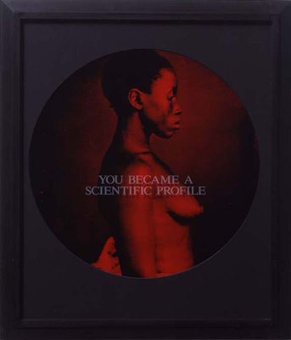
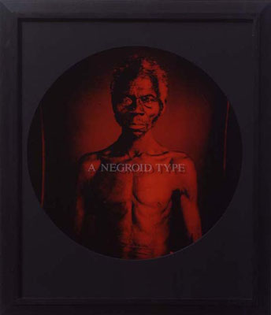
(Figure 1) Carrie Mae Weems, You Became a Scientific Profile, 1995-6,
from the series From Here I Saw What Happened and Cried
(Figure 2) Carrie Mae Weems, A Negroid Type, 1995-6,
from the series From Here I Saw What Happened and Cried

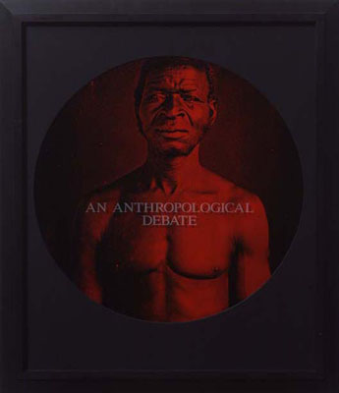
(Figure 3) Carrie Mae Weems, An Anthropological Debate, 1995-6,
from the series From Here I Saw What Happened and Cried

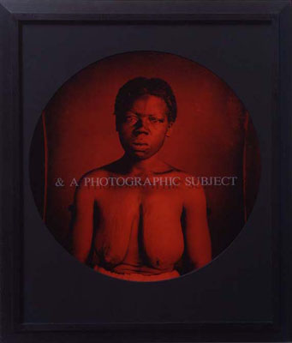
(Figure 4) Carrie Mae Weems, & a Photographic Subject, 1995-6,
from the series From Here I Saw What Happened and Cried

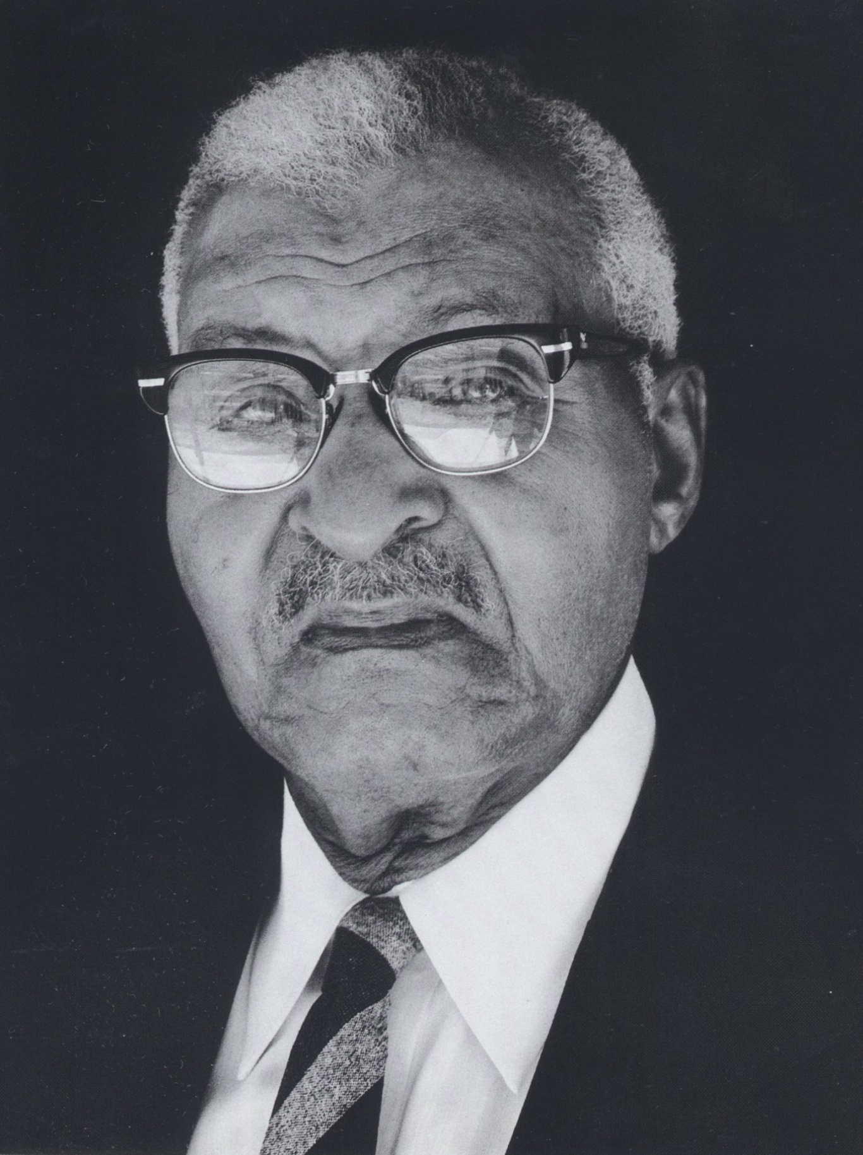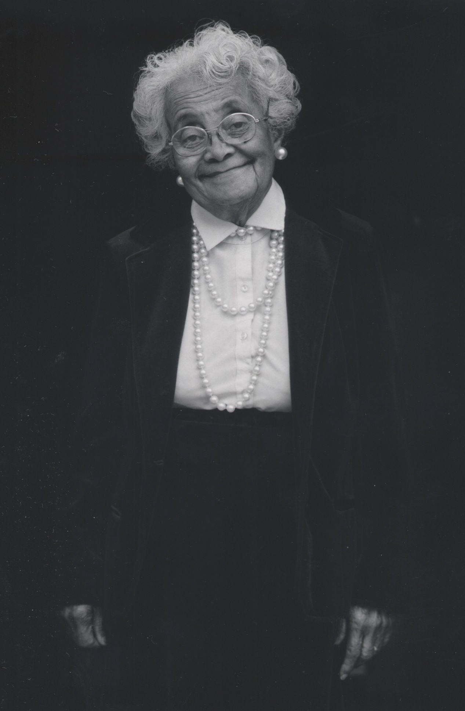
(Figure 5) Raymond Bial, Allen Rivers, 1983
(Figure 6) Raymond Bial, Sarah Scott, 1983
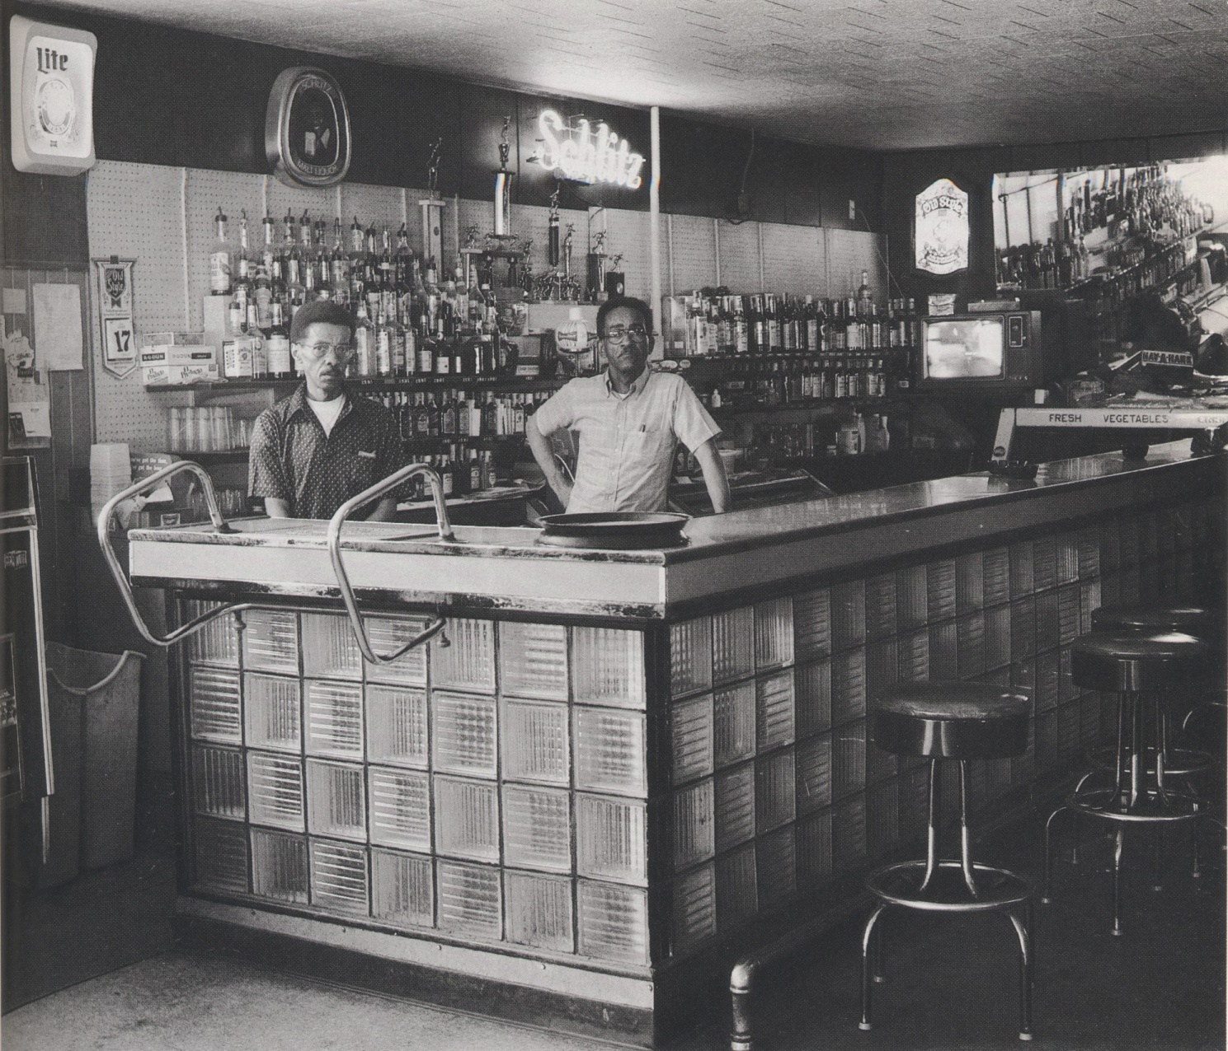
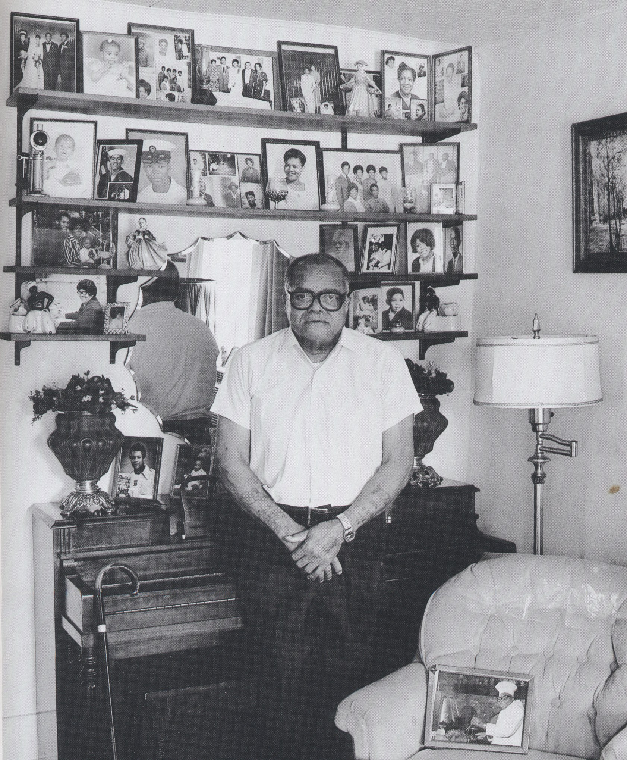
(Figure 7) Raymond Bial, Al and James Baker, 1983
(Figure 8) Raymond Bial, James Algee, 1963
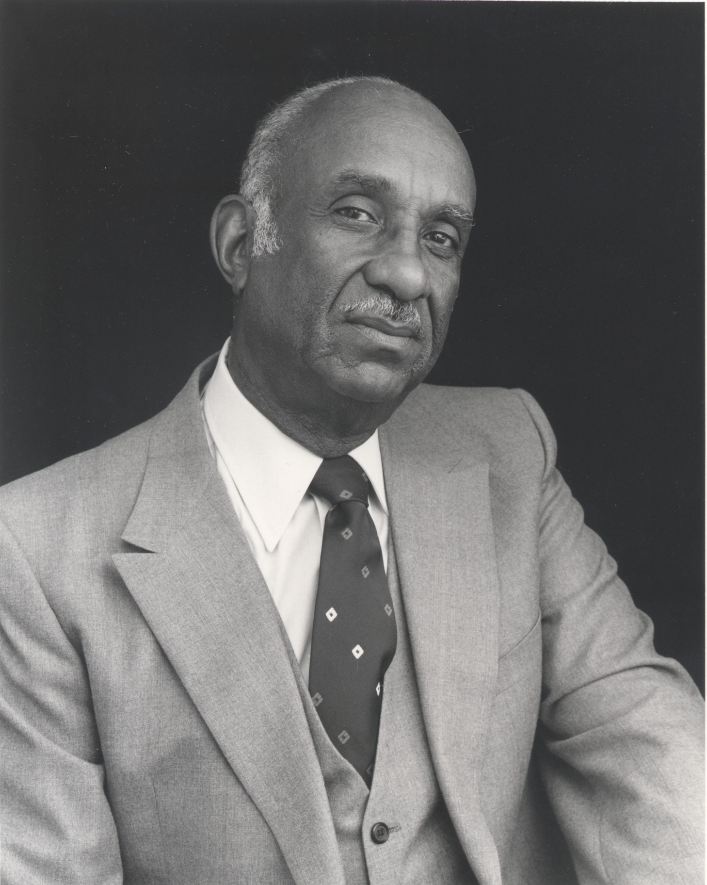
(Figure 9) Raymond Bial, Taylor Thomas, 1983

Charles Guise Contemporary, “Artists: Deborah Willis,” http://www.charlesguice.com/artists_dw.html
Deborah Willis. “Visualizing Memory: Photographs and the Art of Biography.” Spring 2003.
Deborah Willis, “Visualizing Memory: Photographs and the Art of Biography,” Spring 2005.
Raymond Bial, “Introduction,” In All Years: Portraits of Older Blacks in Urbana Champaign.
Raymond Bial Interview (July 7, 2010)
Newspapers catering to Champaign’s black community are as follows: Champaign and Vemilion County Herald; Champaign County Voice; East Central Illinois Voice; the Illinois Times; The Voice of the Black Community; and a bi-yearly newsletter produced by the Early American Museum in Mohamet, Illinois called Through the Years: African American History in Champaign County.
According to the University of Illinois Library Archives website, there has been one dissertation on Champaign-Urbana’s African American community. It was titled, “Champaign-Urbana Black Community Archival Resources” and written by Evelyn E. Brown. Published in Spring 1984, the paper describes the problems associated with gathering data on documentary resources of the black community.
I have arrived at this conclusion through my search for graduate programs in African American art history throughout the United States. I have searched universities throughout the country for concentrations on topics in African American art history, but have been unable to find any. In my undergrad experience at the University of Illinois, I have found that there are no course offerings on African American Art. While I have found that courses on African American art are offered at some universities, I have yet to discover a concentration on African American art.
At the University of Illinois, African Americans artists are not included in American survey art history courses. Those that do mention African American artists only briefly highlight the most famous African American art movement—the Harlem Renaissance. Though this was an important movement for African Americans, the recognition of only the Harlem Renaissance could lead to the inaccurate conclusion that art was/is not being created black artists before and after this time.
Raymond Bial Interview (July 7, 2010).
Deborah Willis, Picturing Us: African American Identity in Photography, p. 23
Exhibitions include: “Posing Beauty in African American Culture” (2009-2012); “Reflections in Black: a History of Black Photographers, 1840 to the Present” (2000-2003); “Picturing Us: African American Identity in Photography” (1994). Publications include: Posing beauty: African American images from the 1890s to the present (2009); African American vernacular photography: selections from the Daniel Cowin Collection (2005); Reflections in Black: a history of Black photographers, 1840 to the present (2000).
Deborah Willis. Picturing Us: African American Identity in Photography, p. 4
Raymond Bial Interview (July 7, 2010)
Raymond Bial Interview (July 7, 2010)
Deborah Willis, Reflections in Black: A History of Black Photographers 1840 to the Present, p. 113
Ibid p. 112
Robert Sengstacke, artist’s statement in Deborah Willis-Thomas, An Illustrated BioBibliography of Black Photographers: 1940-1988 (New York, Garland Publishing, 1989).
Raymond Bial. In All My years: Portraits of Older Blacks in Champaign-Urbana, p. 1
Brian Wallis, “The Dream Life of a People: African American Vernacular Photography” in African American Vernacular Photography, (New York: International Center of Photography 2005).
Deborah Willis, “Visualizing Memory: Photographs and the Art of Biography,” Spring 2005.
Deborah Willis CV, http://admin.tisch.nyu.edu/object/WillisD.html
Ibid p. 23
Leo N. Tolstoy, What is Art, (originally published in 1898), p. 51
E. Barry Gaither, “Social Art, “ The International Review of African American Art 15 no. 1 (1998), p. 61
Deborah Willis, “Biography” in Stanley Crouch One Shot Harris: The Photographs of Charles “Teenie: Harris, p. 108
Paul L. Anderson, The Fine Art of Photography, (originally published by J. B. Lippincott Company 1919), p. 25
Roland Barthes translated by Richard Howard, Camera Lucida, (Library of Congress Cataloging in Publication Data 1981), p. 16
Paul L. Anderson, The Fine Art of Photography, (originally published by J. B. Lippincott Company 1919), p. 25
Raymond Bial personal essay. http://www.raybial.com/bio-essay.html 2008.
Raymond Bial Interview (July 7, 2010)
Raymond Bial. “Introduction.” In All My Years: Portraits of Older Blacks in Champaign-Urbana.
Raymond Bial Interview (July 2010)
Raymond Bial personal essay. http://www.raybial.com/bio-essay.html 2008.
For this paper, I cite the work of the individual students whose research has aided me. I do not cite the primary sources (newspapers, interviews, archival records); however, I will do so for my senior paper.
This data is borrowed from Rick Deja's archival research on Allen Rivers, which he undertook during Fall semester 2009 in the seminar Arth 491.
In 1935, Champaign police commissioned a study to analyze the ratio of African Americans to African American police officers in Bloomington (650: 3), Danville (2,565: 2), Decatour (1, 550: 1), and Springfield (3, 324: 3). Champaign’s ratio was 1, 598: 0 until Rivers was appointed.
This data is borrowed from Rick Deja's archival research on Sarah Scott, which he undertook during Fall semester 2009 in the seminar Arth 491.
Raymond Bial Interview (July 7, 2010)
This data is borrowed from Rick Deja's archival research on Al and James Baker, which he undertook during Fall semester 2009 in the seminar Arth 491.
Ibid.
This data is borrowed from Emily Heaton’s archival research on James Algee, which she undertook during Fall semester 2009 in the seminar Arth 491.
Raymond Bial “Introduction” In All My Years: Portraits of Older Blacks in Urbana-Champaign
This data is borrowed from Stephanie Birch's archival research on Taylor Thomas, which she undertook during Fall semester 2009 in the seminar Arth 491.
Rick Daja, “Allen Rivers,” Fall 2009.
At this point, Allen Rivers was already in the armed services, but he remained the only black police officer for decades before another African American was hired.
Raymond Bial. “Introduction.” In All My Years: Portraits of Older Blacks in Champaign-Urbana.
Deborah Willis. “Introduction.” Picturing Us: African American Identity in Photography. p. 3
Paul Sternberger, Between Amateur and Aesthete: The Legitimization of Photography as Art in America, 1880-1900, p. 6
Brian Wallis, “The Dream Life of a People: African American Vernacular Photography” in African American Vernacular Photography, (New York: International Center of Photography 2005).

