**S.P.E.A.K. CAFÉ** (Song, Poetry, Expression, Art, and Knowledge) is an open-mic public spacer for socially conscious expression about Race, Roots, and Resistance.

**S.P.E.A.K. CAFÉ** is a collaborative university and community project supported in part by the Department of African American Studies and the Krannert Art Museum.

For more information, please contact DAAS at 217.333.7781, Krannert Art Museum at 217.333.1861, or email Aaron Ammons at *livingsoul@sbcglobal.net.*

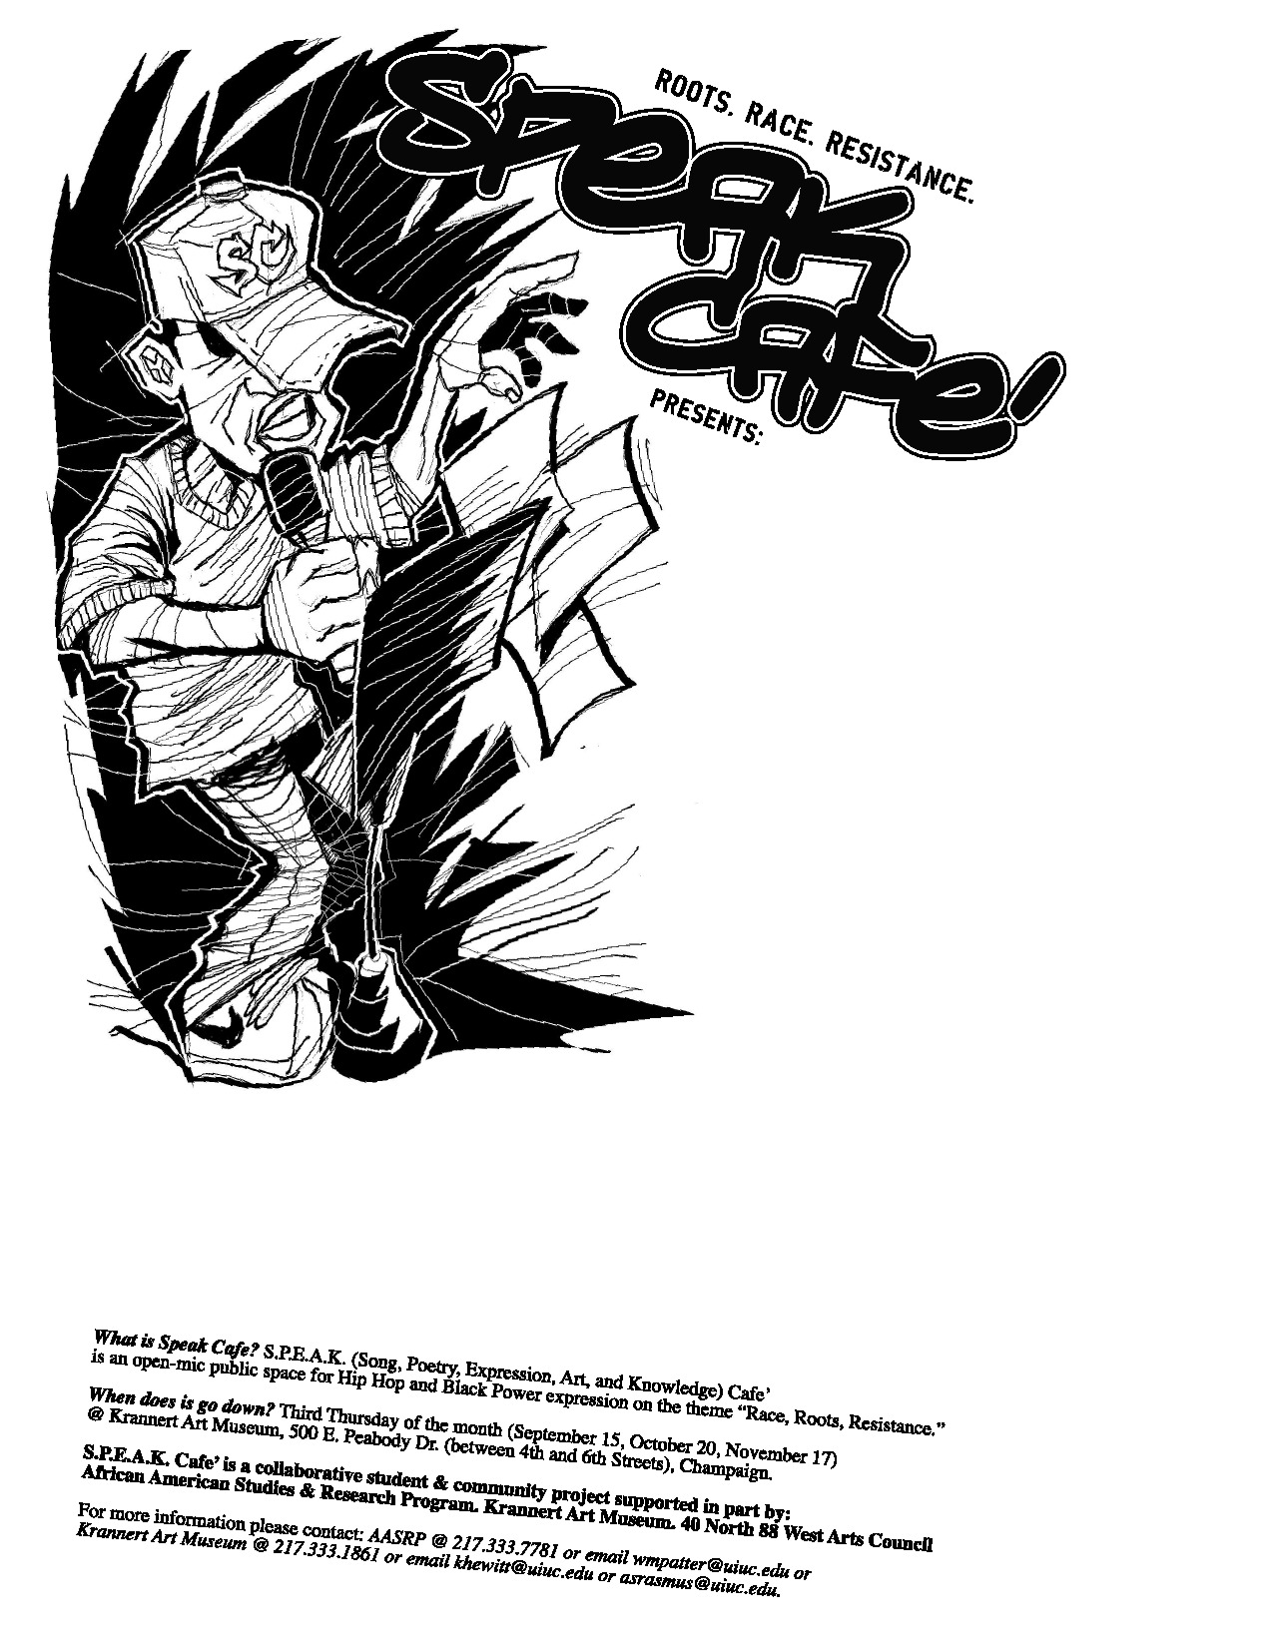

**Free Sweet Potato Pie for the**

**first 20 people.**

**When:** October 7, 2010

**Where:** Krannert Art Museum

500 E. Peabody Street

Champaign, IL 61820

**Time:** 6:45pm – 9:00pm

**I Can Hear It Now, Re-evolution!**