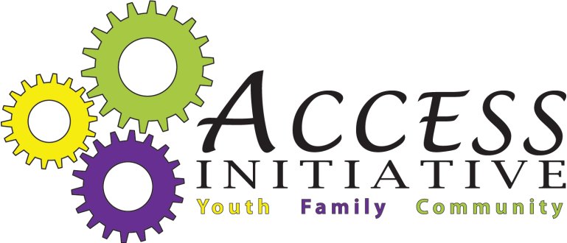
Type of Meeting | Social Marketing and Communications Committee | Date | Friday, January 21, 2011
Place | Juvenile Detention Center | Time | 3:00-5:00 PM

Agenda Items | Person’s Responsible | Desired Outcomes | Handouts | Time Allotted
Introductions/Community Announcements | Committee |  |  | 10 mins
Review and Acceptance of Minutes | Jonte’ Rollins | Recap of previous meeting. Make corrections or additions. | 1/6/11 Minutes | 5 mins
Social Marketing and Communications Coordinator Update | Jonte’ Rollins | Information on SMCC activity |  | 5 mins
ACCESS Initiative Parent Letter | Jonte’ Rollins | Committee feedback and acceptance | Copy of letter | 10
ACCESS Initiative Brochure-1st Draft | Committee | Solicit feed back | Copy of Draft | 15 mins
ACCESS Engagement Events | Committee | Develop a list of event criteria, activities, and presenter guidelines and qualifications |  | 20 mins
Social Marketing and Communications Workgroups | Jonte’ Rollins | Identify members who are interested in working on specific tasks outside of the regular monthly meeting.  -Website Development  -ACCESS Initiative Communications Policy  -ACCESS Initiative Engagement Events  -Black History Month New Gazette AD  -ACCESS Initiative Mental Health Awareness Week |  | 5 mins
ACCESS Initiative Social Marketing Plan | Committee | -Review ACCESS Initiative Goals  -Create Social Marketing and Communication Goals  -Select Primary and Secondary Audiences | Planning Sheet | 40 mins
Closing/Reflection |  |  |  | 5 min

Notes
_________________________________________________________________________________________________________________________________________________________________________________________________________________________________________________________________________________________________________________________________________________________________________________________________________________________________________________________________________________________________________________________________________________________________________________________________________________________________________________________________________________________________________________________________________________________________________________________________________________________________________________________________________________________________________________________________________________________________________________________________________________________________________________________________________________________________________________________________________________
Task | Point Person | Deadline | Date Complete  (or ongoing)

