PTA Meeting
Tuesday September 22
6:30 p.m.

Special Program:

MAPPING MEMORIES: A Very Special B.T. Washington/Douglass Neighborhood Project incorporating the cultural and social history of our community
Speakers: Ken Salo and Nama Budhathoki
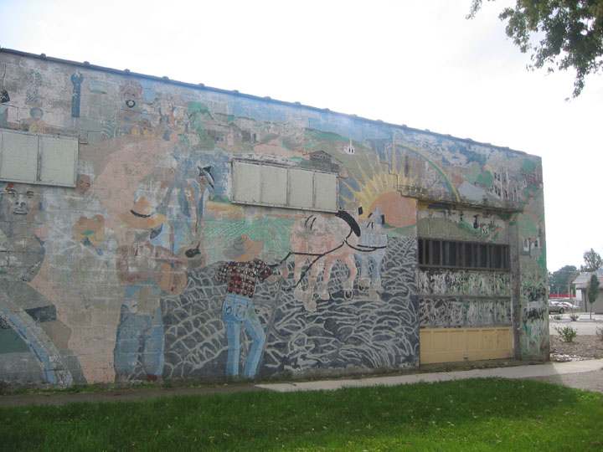

Also: The Annual Walkathon Kick-Off Party!
Learn how you can help earn money to support BT Washington programs for students, families and staff this year!

If you haven’t yet joined B.T. Washington PTA, please consider becoming a member at our first official meeting of the year. Dues are $8 per year and help support local, state and national PTA programs.

Parents and staff of BTW are welcome to attend all meetings and PTA activities; however PTA membership is required in order to vote for officers or at business meetings. As always, we appreciate your participation even more than your money!

