TAP In Leadership Academy: A Lesson in Perseverance and [Collaboration?]
Shameem Rakha
Sally Carter
Chaebong Nam

Community member and scholar Sally Carter is the founder of a new organization for the youth of Urbana-Champaign entitled, “TAP In Leadership Academy” whose four pillars are leadership, cultural awareness, literacy, and civic engagement. Sally realizes something, so many in leadership do not. She realizes that we can’t wait until college to prepare our students to be leaders. We need to start preparing them to be civically active, productive citizens, before they reach middle school. TAP In is preparing tomorrow’s leaders today with a 6-week summer program as well as a daily after school program that focuses on the maths, sciences, foreign languages, and the academy’s four pillars.
Making Connections: A VERY Abbreviated History of TAP In
When her son was in 3rd grade, Sally realized that despite her and her husband’s education, and their personal focus on education with their children, she needed help for her gifted son, but where could she turn? After much searching of programs throughout the community, Sally determined that she would start something different for the families of her community. She would start an after school program that focused on cultural competence, in addition to education and leadership. She would start a program that went beyond tutoring or afterschool care. Originally, Sally wanted to start an after school program in conjunction with the local schools. Though there was some offer for collaboration, the schools required money to help fund the extended hours and janitorial services that would be required by the program. Sally didn’t have any money for these things. Indeed, as her focus would be on reaching families like her own, low to middle income families, she doubted the program would have much money at all.
Light in the Darkness
Trinity B., 6th Grade
After months of leg work, and through many tears, Sally realized her dream for the academy. In June of 2010, TAP-In Summer Leadership Academy opened its doors at the McKinley Foundation on the campus of the University of Illinois. The struggles to find funding for leaders, food, supplies, and a location is that which is written partially about below.
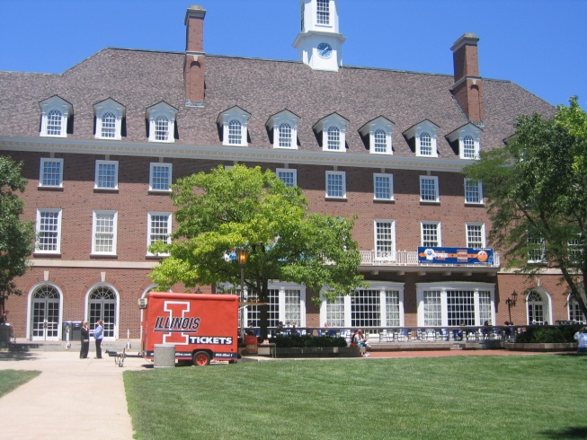
Connecting to the University: A Combination of Joy and Tears

Without a solid location for the program, Sally set off to look for financial support for TAP-In. On a trip to the mall, Sally found the beginning of that support. She found Angela Slates and myself. Sally’s friend Angela and I are graduate students and were serving as Graduate Assistants for the Youth Community Informatics Project in the Graduate School of Library and Information Science Department. As a recent graduate herself, Sally knew that the University had resources, the question, of course, was how to gain access to them. Here, Sally says, “my experiences mirror the experiences of others in the community. I didn’t know what GSLIS was.” Sally thought, “I’m educated and clueless. If I’m clueless, what about others? There is a whole lot we as a community do not know about the University.”
Representation of My Future
Will C., 6th Grade
As a follow up to Sally, Angela, and I meeting at the mall, we gathered to work on a grant. Due to my experience as a graduate student and as a teacher within the community, I had had extensive grant writing experience. Angela brought with her amazing knowledge of the research and of the community, and Sally, of her dreams and plans for the program. In order to get this grant, Sally had to find University sponsorship, which she was unfortunately unable to do before the grant’s due date. Another door seemed to have closed. Sally wondered why it was so hard to bring the University and its resources into the community, but within her wonder she had an idea. If the University would not come and help this program, she would do her best to bring the program to the University.
Sally knew she needed a location for her program, but also knew that without the grant, she would not have the ability to pay to rent a location. On a visit with Sally’s sorority sister and assistant program director to the African American Cultural Center, Sally sat on her soro’s couch pondering, when she offered to house the summer program at the cultural center. With what Sally thought was a commitment from the African American Cultural Center established, and connections with the Native American House, Asian Cultural Center and La Casa founded, Sally moved forward, building a much needed bridge between the “town and gown” so often spoken of in the literature.
Sally created a curriculum that would center on a different cultural group each week of the six-week summer program. Her thought was to have each week at a different cultural center with the African American Cultural Center being the program’s home base. “Nevada street was going to be our campus.” Sally remarked.
Sally met with professionals in the International and Global Studies Department who could teach the scholars about different world cultures. Within days of meeting several people, through personal interactions, Sally had created a roster of interested faculty and staff at the University who would later be responsible for teaching her scholars about world cultures. One of the people Sally met was Monique Rivera, Senior Program Coordinator in the Office of Equal Opportunity and Access (OEOA). Monique soon became instrumental in the development of TAP In Leadership Academy. She offered her professional background in education, her heart for helping Sally develop substantive, holistic curricula, and experienced insight into the professional inner workings of University life. Their connection was instant, and she continues to play a large role in TAP In Leadership Academy, now as a board member.
Armed with a location, food, instructors, and a curriculum, Sally knew she needed staff to help run the program. She could not do this on her own. Sally was able to hire five staff members for the summer program through the Put Illinois to Work grant.
Just four days prior to the program start, merely 2 hours before her parent meeting about the program, the floor fell out from beneath Sally Carter’s feet. Unbeknownst to Sally, the person who had agreed to house the program in the African American Cultural Center failed to get this decision approved by the University administration. When run by the University legal department, the whole program was shut down. Having young people on campus, on a daily basis, was a liability.
Needless to say, Sally was crushed. Months of work were lost in a single swipe of a bureaucratic pen. Hard-fought connections would be severed. Parents and students alike, disappointed. Sally felt angry, lied to, and betrayed. She thought, “the University doesn’t give a damn about our kids.” She recalls that at this time she remembered hearing University person after person asking her what grant she was associated with, or what department she was working with. The answer was always the same, “None. I’m just a community member.” At this moment, the “just” became very large. Sally no longer felt that she belonged on the University campus—her program was “just” for community members. Sally sunk into the deepest of depression, such was this tenacious woman’s devastation.
Every Situation has a Sign to Pay Attention to
Cessily Wilson, TAP In Leader
Despite her depression, Sally called Angela Slates, who in turn contacted Dr. Will Patterson, a lifelong community member and activist and Assistant Director at the African American Cultural Center. Dr. Patterson attempted to allay Sally’s fears and promised to make some phone calls. Sally followed up on a lead given to her by Dr. Patterson which eventually led her to the McKinley Foundation, which not only was located on Campus, but directly across from the GSLIS (Graduate School of Library and Information Sciences) Department, and the International Studies building where all of the professors and professionals who had committed to working with the students each week were located. After such great disappointment, Sally mustered the courage to walk into the foundation and ask for help. She knew she could not pay for a location, but she asked, and this time, the help that was promised, was delivered upon. The McKinley Foundation’s basement is now home to the TAP In leadership Academy.
The McKinley foundation has proven to be an amazing resource for the TAP In project. They have provided several rooms for classes as well as recreation space, and even keep the students and staff fed for a very nominal cost.
Thanks to the University’s “Community Outreach” goals, the scholars had access to University laptops with which to do their web design, research, and photography work. Dean Kalentzis generously offered a set of laptops for the scholars to use for the summer. In addition, Extension Service staff taught the students about food and nutrition.
TAP In Summer Leadership Academy
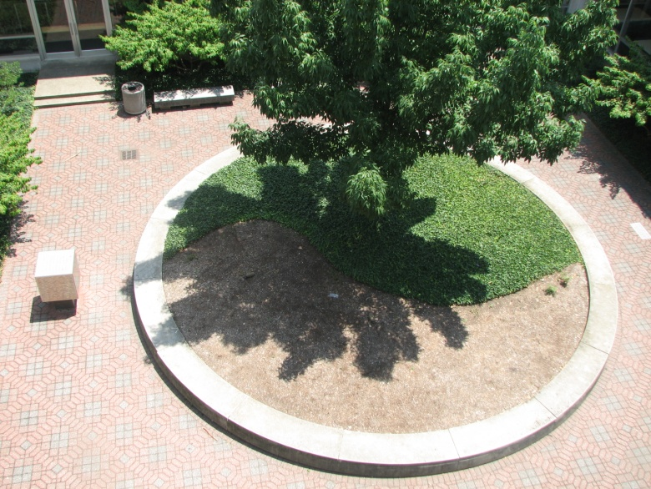
In June of 2010, TAP In Leadership Academy began its six-week program. 11 elementary students and 5 high school students (who served as mentors) participated. 3 of the High School students participated in the afternoon, assisting teachers and mentors, and were paid for through the GSLIS department, Youth Community Informatics project. These scholars had been a part of a summer program a year earlier in which they created a digital asset map of the Northern part of Champaign-Urbana.
Yin Yang Love
Anna L., 7th Grade

From 8 am to 3 pm every weekday for 6 weeks of the summer the scholars learned leadership skills, money management and budgeting, cultural understanding, health and nutrition, web design, and digital photography. Each of the enrichment activities were taught by people who understood and respected the culture and behavior of the scholars.
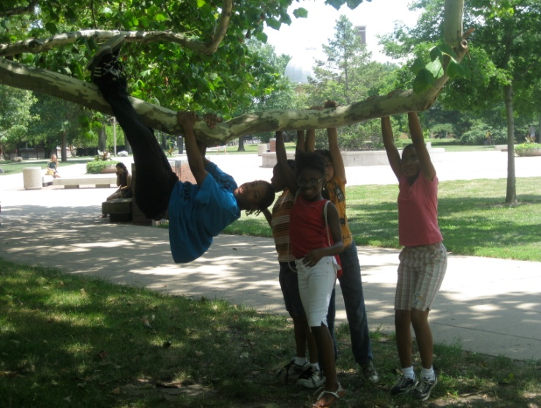
The summer program ended with an open house in McKinley Foundation’s Westminster Hall. The hall was beautifully decorated with tri-folds displaying the scholars dream jobs. Also displayed were the scholars photographs, various artworks such as masks, wood houses, and wire-works. Scholars, parents, family members, other community members, and YCI people celebrated the scholars’ and program’s meaningful achievement. Sally became quite emotional, finally bursting into tears, while opening the showcase. When someone gave her a small piece of napkin, Sally said, “Oh, no, I need a whole roll!” It was not until I learned of her struggles getting this program going, did I fully understand the meaning of her tears.
The Tap In Family
Jazzlyn Carter, Freshman
The TAP In / Youth Community Informatics Connection
Angela Slates, Chaebong Nam and I , all Graduate Assistants for the YCI project, worked together in determining what work we would do with the scholars throughout the summer. We knew we would have two hours a week for a total of six weeks. As one focus of YCI is that of empowering youth to tell their stories, and another is digital media, our topic was easily decided upon. Though Chaebong would be left without Angela or myself for the bulk of the sessions, with the help of 3 paid High School interns we would teach the scholars to take and edit digital photos in order to tell a story of some kind.
In the session during the first week, Chaebong and I, went together to the basement of McKinley Foundation where there were about twenty people including TAP In scholars, Junior leaders and adult leaders. After introducing the our project idea and ourselves, we talked with the students about photography and what makes a good photograph. We also did some basic introductions on how to use the cameras loaned to the program through YCI. Next, we all went outside to let scholars play with the cameras. On the Quad, the central large square on campus, the scholars, in groups with youth leaders, took turns taking pictures of anything that was of interest to them.
In the second session, Chaebong, who was leading class that day, shared photography books she had checked out from the Art and Architecture Library. She asked the scholars to choose one book and find three favorite photos in it to be shared with the others. They also had to answer “why” they chose them.
There was a small incident while the students were examining the photographs. One young staff surrounded by four or five scholars urgently called Chaebong, “Miss Chaebong, there is an inappropriate picture in this book!” Chaebong went to this group and they showed her a couple photos of a woman who was nude. Chaebong thought, “Oops, I should’ve checked those books more cautiously.” She explained to them, “You don’t necessarily have to think these photographs are inappropriate. This is considered to be a part of art. The photographer is trying to show an image of women in a very naturalistic way. It is part of naturalism.” Chaebong did not want scholars to get the impression of nudity equaling pornography. She took this as an opportunity to teach.
During the third and the forth sessions, Chaebong, who again was in charge, took the scholars out in the field to allow them to take photos. One location she brought them to was the Japanese Garden. Before taking the photos, she asked the students to keep the theme for taking their photos, such as signs, buildings, nature, whatever they liked, in mind. She reminded them that their pictures could tell a story.
During the 2nd of the two sessions in the field, it was extremely hot and humid, but the scholars did not complain at all. Instead, they were diligently walking around the campus here and there and taking photos with their team partners. On our way back, a couple of the scholars proudly showed Chaebong their work.
With only two sessions left, Chaebong downloaded the photographs and taught the students how to edit their photos. Although it was a bit mess at the beginning trying to figure out which team was using which camera with whom for the past three weeks, it eventually turned out well and everyone got their own photos. Chaebong had the students choose their five favorite photos. She had them type up their theme as well as the reasons they chose the particular photos.
Sally and Chaebong put the scholars’ favorite photos on Facebook to be shared with the public. In the final session, the scholars presented their work that had been uploaded to Facebook to several thrilled adults. Each scholar introduced their favorite work along with their photographic theme and their thoughts. All of us in the room enjoyed the scholars’ achievements and appreciated their own aesthetic views seen in various images. The scholars created photo cards for each of their favorites photos which were matted, displayed at their program showcase, and sold as a part of a fundraiser for TAP In.

At the end of the showcase, Tap-in sold the nicely matted photographs to raise money for the programs future. People, amazed by the scholars’ work, happily purchased them. Words such as, “Did you get that, too? I love that Ying-Yang!” “Look at this flower. This is gorgeous,” rang throughout the hall. The students beamed with pride.
Though the YCI grant has ended, Chaebong and I are committed to the total success of this program. We plan continue working with the scholars throughout the school year to develop a book that will document the wonderful work of the scholars and of the amazing impact of TAP In.
Standing Out
Arnold B., 5th Grade
Specific Accomplishments and Stories of the TAP In / YCI Connection
According to Sally, the scholars’ participation in the photography project, “showed the kids that what they see in the world is not as gloomy and crappy as they think. That their world is beautiful.” The Youth Community Informatics Project involvement introduced the scholars to abilities they didn’t know they had. In reviewing the project, it would appear that this is true for the TAP-In project in general.
Sally shared this story about Anna, who came into the program as a very angry young woman.
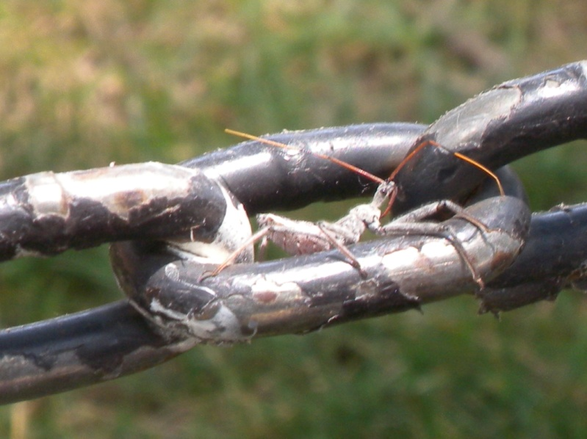
Had you asked Anna where she was from, she would have said California, but the truth is that she is from Guatemala. She did not think there was anything pretty about her, and she was a bully. Anna had all of these things going against her according to society. But when Anna got the camera, the things she saw were so beautiful. But even more beautiful were the people around her telling her how beautiful her work was. I was so proud when on showcase day, everyone was choosing her photographs as their favorites. Anna didn’t know what she wanted to do when she grew up, but now she knows she wants to be in the arts. YCI
Adaptation
Anna L., 7th Grade
put a dream in a kid’s hands. It was important. She has the eye for capturing beauty. Anna’s own eyes gets lazy and wonders. . People look at the outer and want to make that a negative, but look what that eye can see!
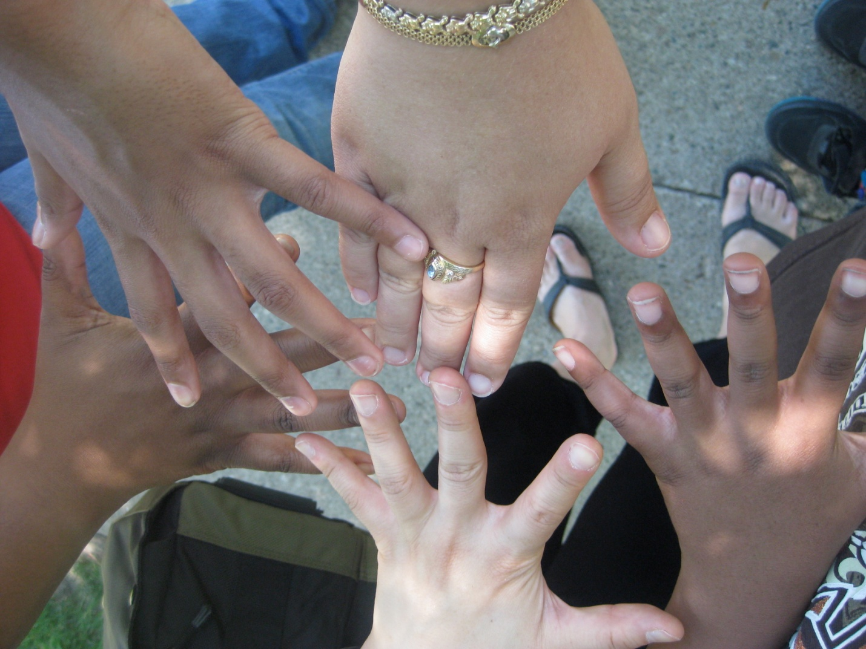
Jazzlyn Carter, 14
“We were on the quad and I saw different colors, races and ages talking and laughing together.
I thought, “Isn’t it cool that one program brought all these people together.”

