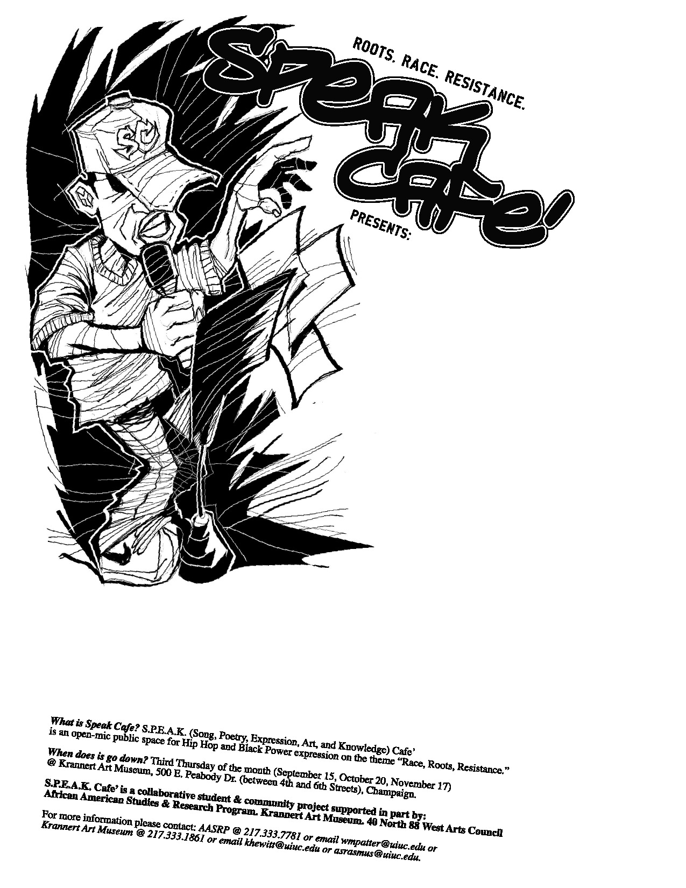
Free Sweet Potato Pie for the
first 20 people.
S.P.E.A.K. CAFÉ (Song, Poetry, Expression, Art, and Knowledge) is an open-mic public spacer for socially conscious expression about Race, Roots, and Resistance.

S.P.E.A.K. CAFÉ is a collaborative university and community project supported in part by the Department of African American Studies and the Krannert Art Museum.
For more information, please contact DAAS at 217.333.7781, Krannert Art Museum at 217.333.1861, or email Aaron Ammons at livingsoul@sbcglobal.net.
I Can Hear It Now, Re-evolution!
When: October 7, 2010

Where: Krannert Art Museum
500 E. Peabody Street
Champaign, IL 61820

Time: 6:45pm – 9:00pm

