EDGAR HOULTS AND THE STRUGGLE FOR RACIAL EQUITY IN THE CHAMPAIGN COUNTY CRIMINAL JUSTICE SYSTEM

Kerry L. Pimblott

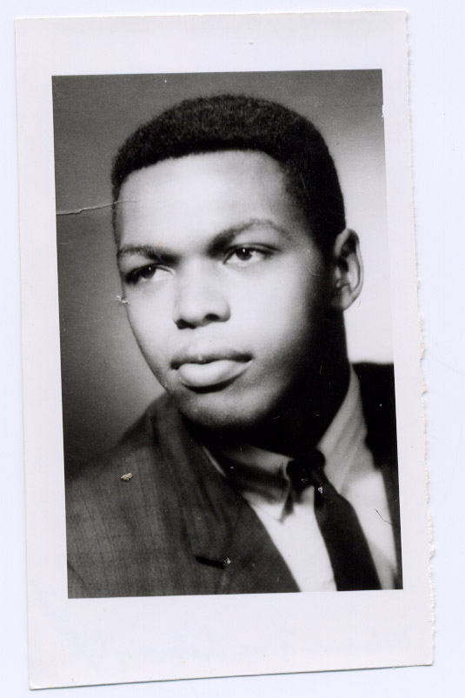
Edgar Hoults, 1970
Photo available at the Champaign County Historical Archives at the Urbana Free Library.

On the morning of April 29, 1970, Edgar Hoults, a twenty-three year old African American man was shot and killed by a local police officer near his home in Urbana. Edgar, an employee of Follett’s Book Store, had been unable to sleep and decided to visit with friends who were working overnight at the store. Earlier in the week, a series of firebombings had taken place leaving Follett’s in need of late night repairs. According to the store manager, Anthony Fernandez, Edgar “horsed around” briefly with his co-workers and then left.

Nearby, Champaign police officers Fred Eastman and Robert Soucie were on patrol. According to police accounts, the officers witnessed Hoults drive north on Wright Street running two stop signs. In response, the officers turned on their siren and engaged Hoults in a high-speed chase. After a few minutes, Hoults lost control of the vehicle and slammed into a fence. Despite the impact, he was able to pull himself out of the car and began to run through an open field with Eastman in pursuit on foot.

The details of what followed are contested. However, what is clear is that Eastman pulled out his .33 caliber revolver and fired. The hollow-point bullet, designed for maximum impact, traveled approximately 50 yards across the field striking Edgar Hoults in the back of the head causing his death. Eastman claimed that he had slipped while firing a warning shot in the air, accidentally causing Hoults death. However, reports to the contrary quickly emerged. Several African-American eyewitnesses argued that Eastman hadn’t stumbled, but rather carefully taken aim at his victim. Others claimed that Hoults had put his hands in the air as a sign of surrender.

Public officials struggled to locate a reason for Hoults evasion of local officers during a routine traffic stop. He had no outstanding warrants and had never been convicted of a crime. By all accounts Edgar Hoults was a sober family man with a promising future. Left behind was his pregnant wife, Alice, and two small children. The only motive police could identify was that he had been driving without a valid drivers license.

Many African American residents were less baffled by Hoults’s frantic decision to flee from local police officers who were widely considered to be racist and corrupt. Mirroring events in cities across the country, protests against racial inequity and police brutality occurred intermittently throughout the 1960s and 1970s in Champaign-Urbana. Longstanding organizations like the National Association for the Advancement of Colored People (NAACP) and the Urban League were joined in the struggle by newer organizations like the Concerned Citizens Committee (CCC) and the Black Action Council for United Progress (BACUP).

The death of Edgar Hoults triggered a community-wide struggle for racial equity in the Champaign County criminal justice system that continues to resonate. A loose coalition of civil rights organizations, community members, and college students quickly mobilized to protest police brutality against African Americans, demand the reorganization of lily-white law enforcement, and ensure that an independent investigation into the Hoults shooting be performed. Concerned citizens flooded city council meetings expressing their outrage. University students staged mass protests, the largest of which took place on May 11 when 1,500 people assembled on the quad. Hoults’s death resonated particularly amongst black students, many of whom, due to restrictions in university accommodation, had been housed by African American families in the North End forging close experiential and political ties. As testament to these deep feelings of solidarity, black students successfully pushed for the fledgling Afro-American Culture Center to be renamed after Hoults in a ceremony facilitated by both student and community activists.

Widespread fears about the independence of the investigation into Hoults’s death were confirmed on May 13 when Howard Mitchell, the director of the Community Relations Committee, castigated local police and city officials for their negligence. “The only city investigation that can be considered extensive,” Mitchell claimed, “has been my own.” When faced with demands for information about the Hoults case, police authorities failed to cooperate forcing the Committee to seek the aid of higher authorities on numerous occasions. For their part, city officials had demonstrated a lack of consideration for the victim’s family and the local African American population. “Naturally, the city was on the spot,” Mitchell explained, “but a man was dead and no one seemed willing to say ‘I’m sorry’ without being reminded.”

Though the State’s Attorney, Lawrence Johnson, initially opted to file charges of voluntary manslaughter against Eastman, tremendous public pressure ensured that when the trial began in October the murder charge was resurrected. Amidst high security, Judge B. E. Morgan presided over a packed courtroom as several eyewitnesses took the stand to testify that Officer Eastman had intentionally killed Edgar Hoults. After the prosecution presented its case, the defense brought out Eastman and several fellow police officers, none of whom had been present during the shooting, to corroborate Eastman’s story of accidental death.

Despite the testimony of several eyewitnesses to the contrary, an all-white jury took less than two and a half hours and one vote to find Eastman not guilty of murder and involuntary manslaughter. At the most fundamental level, the all-white jury had been more convinced by the testimony of a white police officer than that of multiple African-American eyewitnesses. As one juror explained, “We believed he was honest when he said he slipped and fell, and that the killing was accidental.” Finding no justice in the criminal proceeding, Alice Hoults filed a civil suit on April 30, 1971. Her struggle continued until 1976 when she finally reached an out of court settlement for $59,000. After more than five years, Alice Hoults ended her bitter struggle for justice and reparations.

However, the collective struggle for racial equity in the Champaign County criminal justice system continues. The prevalence of all-white juries, the lack of police accountability, and well-established racial disparities at each stage of the process demands that we continue to work in close collaboration for the furthering of freedom and justice in our communities.

