The Don Moyer Boys and Girls Club
Learning Center Redesign by Deven Gibbs
Independent Study Supervisor: Sharon Irish, PhD.
School of Architecture, University of Illinois at Urbana-Champaign
Click here to view our Youtube video

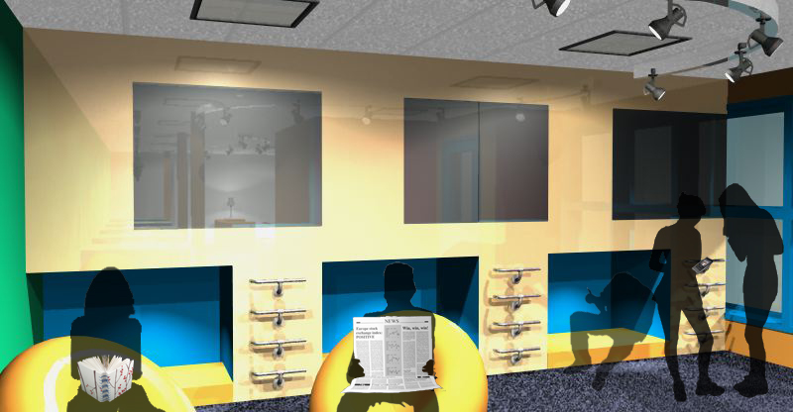

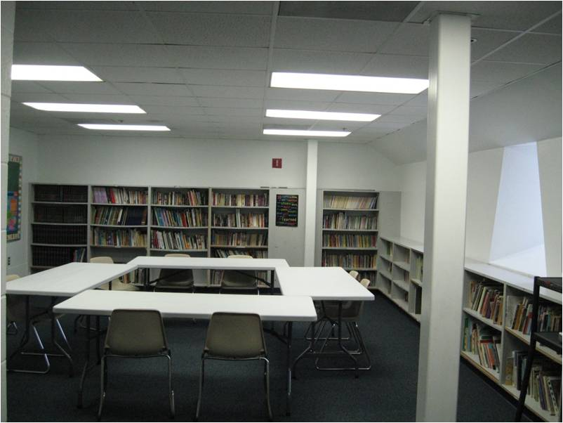
The Need for [Re]design
inefficient space use
harsh lighting
absence of color
need for interactive arrangements
The existing Learning Center at the Don Moyer Boys and Girls Club
comfort

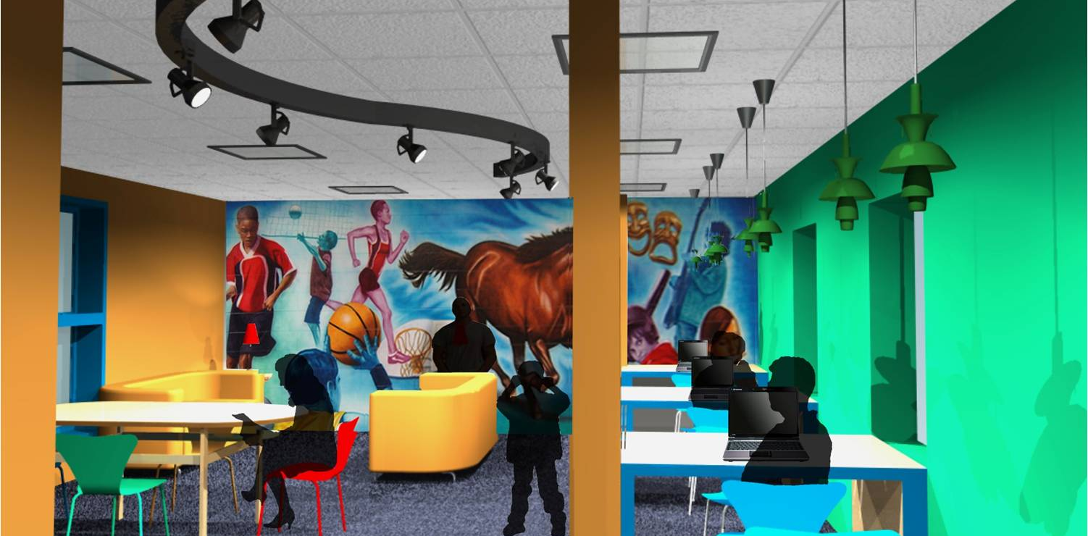

When asked to redesign the existing computer lab and learning center of the Don Moyer Boys and Girls Club, I created a space that will inspire creativity and collaboration in an informal setting for K‐8 students. The new space will have ample storage for all program uses and the equipment necessary for that program.
The redesign proposes a new lighting scheme and various furniture and materials for about 20 students.

Color
I propose that there be color brought into the Learning Center space. To inspire creativity I have chosen that these colors be.
I have chosen colors--red, green, blue, and orange--to delineate the various spaces within the center. Blue is used for the quieter individual workspaces.

Lighting
A multifunctional space should be lit in layers. By layering the lighting--track lighting, linear fluorescent lighting, recessed can lighting, and natural lighting-- the user has options suitable for different activities

Acoustics
Acoustical considerations are vital in multifunctional and sound sensitive spaces. The existing acoustic tile ceiling will be supplemented with carpeting the current tile floor.

Carpet tile works well for sound absorption. Aesthetically, it adds color and warmth to a space.

Furnishings
Having a variety of comfortable seating options allows for flexible use of space, and allows people to feel comfortable within a space. For this project I chose a combination of office chairs, bean bag chairs, couches, and seating cushions.

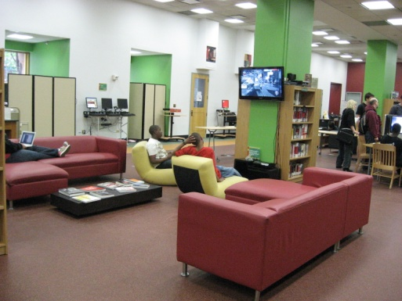
The office chairs should be lightweight and have wheels on the bottom to allow for ultra-portability. The height of the chair should be adjustable to accommodate a variety of users.

Having bean bag chairs that can be easily moved is a way to promote gaming, reading, and relaxation and create a fun atmosphere.

Couches are great in that they inspire collaboration. They also create a relaxed and homey feeling within a space.
Site: YouMedia at the Harold Washington Library in Chicago

The seating cushions for the Cove are designed to fit inside of each cubby or to be turned perpendicular to accommodate two users. They can be totally removed from the space if user chooses to move their activities elsewhere.

Spatial organization

Since laptops can be use virtually anywhere, there should be accommodations for laptops everywhere within a space. Desks designed for laptops should have electrical hookups to decrease the distance a user has to stretch their cord. There should be space for individual and group work using laptops.

Printing stations should be centrally located but should be place on a table with wheels so that the station(s) can be moved through the space.

Student production
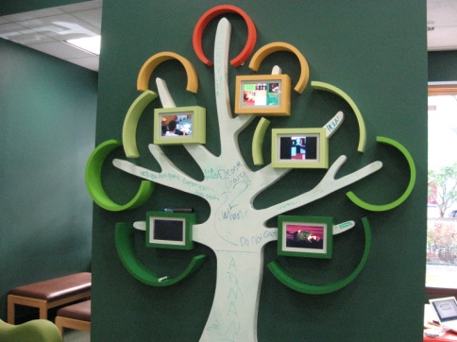
Creativity and a sense of psychological and emotional well-being are promoted by the use of art work and plants. Exhibiting art work created by patrons of the community center promotes a sense of accomplishment and pride.

Digital display of projects
Digital picture frames and/or display screens are an economical way to keep numerous user designs visible.

Site: YouMedia at the Harold Washington Library in Chicago

