
Public Works Department • 702 Edgebrook Drive • Champaign IL 61820
(217) 403-4700 • fax (217) 403-4755 • www.ci.champaign.il.us

NEWS RELEASE

Date: March 16, 2010 Contact: Lisa Nichols Tom Schuh
Secretary I Operations Manager
217.403.4777 217.403.4770

CITY OF CHAMPAIGN SPRING YARD WASTE COLLECTION

This year, the City of Champaign Spring Yard Waste Collection program will run from April 5 through April 30, 2010. This collection is available to all residential properties in the City of Champaign within City limits at no charge. This program will provide a green alternative for yard waste disposal.

Residents may participate by simply placing bagged leaves or bundled branches and twigs at the curb by 6:00 a.m. on their scheduled collection date. Residents should refer to the map and schedule below to determine their collection dates. (Map reflects general City boundaries only.) Residents should note that on heavy collection days, collections may occur later than normal or even the next day. Materials not collected by the end of the following day should be reported to Public Works at 217.403.4770.

More information on the program can be found on the City’s web site at www.ci.champaign.il.us and on the City’s television site, CGTV-Cable Channel 5. Residents are also encouraged to sign up for automatic e-mail notification of this and all future yard waste collections at the City’s web site.

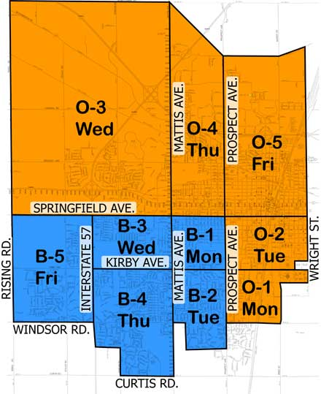
Zone |  | Collection Days
Orange Zone
O-1 | Mondays: April 5 and April 19
O-2 | Tuesdays: April 6 and April 20
O-3 | Wednesdays: April 7 and April 21
O-4 | Thursdays: April 8 and April 22
O-5 | Fridays: April 9 and April 23
Blue Zone
B-1 | Mondays: April 12 and April 26
B-2 | Tuesdays: April 13 and April 27
B-3 | Wednesdays: April 14 and April 28
B-4 | Thursdays: April 15 and April 29
B-5 | Fridays: April 16 and April 30

