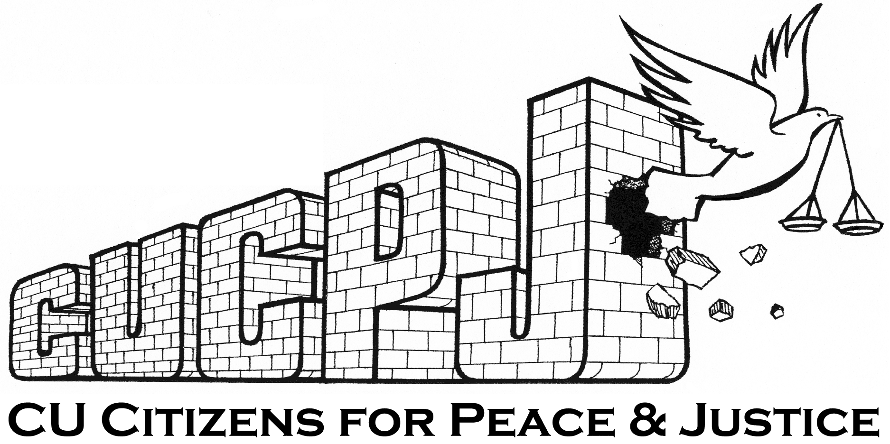

Recommended Improvements
City of Champaign
Citizen/Police Complaint Process

- Amend current system by creating separate forms and procedures for public filing of police complaints and compliments. They serve two distinctly different purposes and by including both in the same form and process cause undue confusion with the general public.

- Change the current title “Public Safety : Employee Conduct Form” to “Citizen / Police Complaint Form and Process” to improve clarity and specificity with the public.

- Provide at minimal two different physical locations to file a complaint such as the police station and city hall with a designated CPD Staff Officer and a designated HRC or city legal department staff person. Each designated individual should be trained to recognize and support a citizen’s right to file a complaint without interference or personal discouragement.

- Upon completion of the complaint form, the citizen should immediately receive a signed and dated copy of the form before leaving the location where the complaint was filed.

- Recently filed complaints should be officially recorded and jointly reviewed by a designated CPD Command Officer and designated HRC or city legal department staff person. As soon as possible, a joint follow-up conference should be scheduled with the complainant. The purpose of the joint conference would be to review and clarify filed information, collect additional information as needed, and review with the complainant his/her options as to how to proceed.

- Citizen/police mediation should be added as an option in the complaint process. It would serve as a VOLUNTARY alternative to the internal investigatory process of the police department.

- Whether mediation or the internal investigatory process is selected, each process should be completed professionally and expeditiously within forty-five days.

- If unsatisfied with the disposition of either process, the appeal process should be expanded to include not only the City Manager, but also a non-city employee such as the chairperson of the HRC or a Civilian Police Review Board.

- A detailed report of all citizen/police complaints and their dispositions should be forwarded to the HRC each month.

- In compliance with Gekas vs. Williamson, written complaints, associated documentation and findings, as well as their disposition should be permanently stored in a legally compliant file during the duration of the officer’s employment with the city. These records should be accessible to the public when properly requested as instructed by law. This may be a file other than the officer’s personnel file.

- An easy to read informational pamphlet should be produced by the city explaining the philosophy, purpose, and process for filing a police complaint. Pamphlets should be distributed and placed in locations of public access such city hall, police station, libraries, and churches.

- The city citizen/police complaint website should be updated to reflect these changes.

