We seek to provide the means for people whose communities are in economic crises with high unemployment, drugs, violence and poor housing. We teach them to be agents for community empowerment and community transformation. 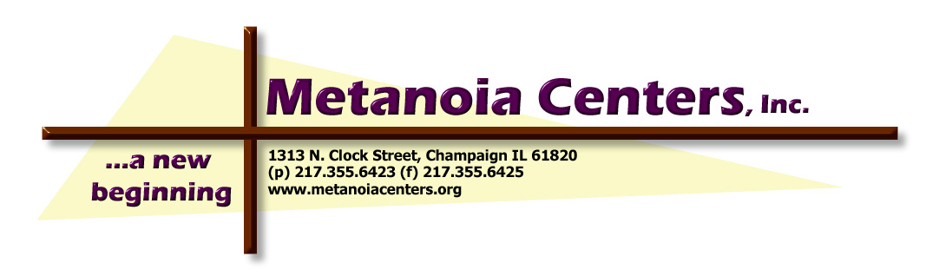

RATIONALE FOR THIS PROPOSAL
The cities of Champaign-Urbana had experienced a sustained commercial and public construction boom that is now beginning to sour, yet residents of the cities, and in particular residents of depressed inner-city neighborhoods, have benefited very little from this period of high economic activity. This is an opportunity lost, since many construction trade unions are facing an aging workforce while unemployment among able-bodied, capable young men and women remains unacceptably high in some city neighborhoods.
In some government-funded building projects good faith efforts have been made to include minorities and women in the workforce. Metanoia Centers for Innovation in Health, Welfare and Social Services, in partnership with many community groups, proposes to negotiate Community Benefit Agreements to build on the successes of recent agreements and to insure that future building project in our region leverage their power to create well-paying, lasting jobs in the construction industry that will directly benefit residents of poor neighborhoods as well as strengthening the local workforce and its labor unions.
Community Benefit Agreements (hereafter “CBAs”) are written agreements between the owners and/or developers of the project and representatives of the community affected by the project. These representatives can include elected bodies such as a city council, and also citizens groups such as neighborhood associations, church groups and community organizations. CBAs are contracts and the courts have upheld their legality and binding nature. In addition to employment, CBAs can cover a wide range of issues relating to the impact of the project at hand, including environmental impact, traffic, parking, and noise mitigation.
These proposals are focused on construction projects with state and federal funding with a construction budget of $1 million or more. The concept of CBAs is most clearly defined in cases where public funds are involved. However, it is the intention of METANOIA CENTERS FOR INNOVATION IN HEALTH, WELFARE AND SOCIAL SERVICES and its allies to create a climate and a set of practices in which local hiring on projects of all sizes is seen as a direct benefit to all — government, the business community, contractors and the unions, as well as residents of distressed neighborhoods — and that the practice be adopted as widely as possible.

The owners, governing board and/or developers of the project will agree to sign a binding Community Benefits Agreement for publicly funded projects with a budget of $1 million or more, an agreement that should contain the following five articles relating to the construction of the project. These five articles are not intended to preclude other issues that may also be addressed in the CBA.

1. COMMUNITY BENEFITS COUNCIL. The owners, governing board and/or developers of the project will agree to recognize, and to include in the decision-making body overseeing the construction project, a Community Benefit Advisory Board selected by the community partnership that is signatory to the CBA, with roles defined below. This council may include faith communities, labor unions, advocacy groups, NAACP, neighborhood organizations and/or tenants’ associations.

2. COMMUNITY BENEFIT ADVISORY BOARD. The owners, governing board and/or developers of the project, in consultation with the Community Benefit Advisory Board as agreed in Article One above, will hire a professional, qualified Compliance Agency at least six months prior to the projected start of construction in order to facilitate outreach and recruitment of new apprentices in time to begin actual work on the project. The first duty of the Compliance Agency will be to draft an agreement with the relevant construction trade unions, if the project is to be a union job, or with the contractors if the project is to be non-union, reflecting the CBA’s goals, including hiring residents of poor neighborhoods and hiring minorities and women. The employment contract of the Compliance Agency will require that the Community Benefit Advisory Board be informed by the Compliance Agency of any action by the owner, developer, general contractor or construction manager that makes it impossible or unduly difficult for the firm to do its job. The cost of the compliance structure and staff will be considered part of the project costs, starting from when the Compliance Agency is hired until the construction is completed and the building occupied.

3. PRE-APPRENTICESHIP PROGRAM. The owners, governing board and/or developers of the project will either facilitate creation of a program, or support an existing program for pre-apprenticeship training and support services. The pre-apprenticeship training will serve residents of the municipality where work takes place and will prepare them to work on the project. Where appropriate, the support services shall address barriers to employment and retention, such as education and “soft skills” and adequate transportation. The role of the Community Benefit Advisory Board shall be to insure that the program created or selected has the capacity to provide a sufficient number of targeted residents to meet the goals agreed on in Article Four below, and to report to the community any problems or areas for improvement that occur in the pre-apprenticeship program and support services. The pre-apprenticeship program and support services shall be considered part of the project costs, unless other funding sources are obtained and agreed on by the Community Benefits Council.

4. LOCAL HIRING GOALS. The owners, governing board and/or developers of the project shall agree to a goal specifying the contract hours on each contract that shall be performed by residents of the municipality where the work is performed and by residents of distressed neighborhoods. METANOIA CENTERS recommends the following terms:
· Fifty percent (50%) of all contract labor hours are to be performed by residents of the municipality where the work takes place.
· Fifteen percent (15%) of the contract hours are to be performed by workers who reside in census tracts that are 20% or more below the federal poverty guidelines, an additional fifteen percent (15%) shall reside in census tracts that are 40% or more below the federal poverty guidelines (30% total).
· The Compliance Agency shall monitor the above goals to insure that the percentage of minority participation equals or exceeds the overall percentage of minorities in the municipality where work takes place (as counted by the latest United States Census), and that at least ten percent (10%) of all contract labor hours are performed by women.
If minority and women participation falls below those levels, the Compliance Agency and the owner, governing board and/or developer shall devise additional means to recruit, train and support minorities and women. The Compliance Agency shall report monthly to the Community Benefit Advisory Board and the Community Benefit Advisory Board shall report at least every six months to the general public on the status of the project in meeting the goals set forth in Article Four.

5. MONITORING. The Compliance Agency shall establish a system for monitoring the contracts’ actual use of apprentices, minorities and women. Said system shall set forth a practice of tracking apprentices through every stage of the application and training process through the use of the Illinois State Department of Labor and other applicable records. The monitoring system shall remain in place for the life of the project and maintain records of workers who enter union apprenticeship programs and their retention rates. These records shall become the property of the Community Benefit Advisory Board when the project is completed, so that further monitoring is possible. The system shall include METANOIA CENTERS FOR INNOVATION IN HEALTH, WELFARE AND SOCIAL SERVICES and/or other non-profit organizations as partners in recruitment and outreach and shall encourage the expansion of the number and capacity of certified training providers. The owner and/or developer, working with the Compliance Agency, shall establish contract specification language to implement both the apprenticeship requirements, monitoring requirements and the workforce diversity goals. Said language shall be included in all applicable contracts. The Compliance Agency shall review each contract as needed, but at least on a yearly basis. If a contractor has not complied with the work hour agreements in their contract, they shall be eligible for a 10% fine on the face value of the contract.
SUMMARY:
Goals of the Community Benefits Agreement for construction jobs
• Hire at least half the workers for the job from the city where the work takes place.
• Hire at least thirty percent of those workers from distressed neighborhoods.
• Ensure that minorities are represented in proportion to their numbers in the community.
• Ensure that women have equal opportunities.
• Create pre-apprenticeship training and support systems so that inner city residents will be ready and able when the jobs open up.
• Ensure accountability and success for all agreements with monitoring, problem-solving and penalties for non-compliance.
• Give workers the opportunity for lasting, well-paid jobs in the construction industry that go beyond any particular project.
• Community partners will form a Community Benefit Advisory Board to report to the public and ensure that the goals of the Agreement are being met.

